Chapter 1

Abstract

The analysis of biomedical datasets is no straightforward task, every dataset has its own challenges and needs di erent approaches to overcome those. The goal of this thesis is to develop a framework that guides biomedical engineers in their initial steps of data analysis. Four representative dataset types are used for application and evaluation of the framework: microarray, mass spectrometry, clinical and survey datasets.

First feature selection methods are developed for microarray and mass spectrometry datasets. Experiments with tuning parameters of lter methods show that none of the datasets needed more than 200 features to explain the output, as additional features did not increase the quality signi cantly. Unexpectedly, results show as well that wrapper methods outperform both lter and embedded methods in feature selection in both quality and feature preservation. Furthermore, the automated machine learning tool TPOT is signi cantly improved for datasets with a high number of features after adding a bias to feature selection methods as well as adding additional feature selection methods.

Secondly methods to handle missing values are investigated for clinical and survey datasets. The results show that features with more than 15% missing values are very hard to cope with for missing value handling algorithms and usually are better to be removed. The distribution of features with missing values are better preserved for imputation methods than for list deletion methods and of the imputation methods nearest neighbour imputation algorithm performed best. After investigating the quality of the datasets with list deletion or imputation, however, a simple mean imputation method outperformed other imputation methods, showing that more complex imputation methods are not needed for missing value handling.

Thirdly the metalearn package was analysed for its exploration capabilities. This package showed to be capable after several extensions to create insight into several dataset issues and how to cope with them.

The outcome of this thesis creates a basis for the computational biology framework. This framework comprises of recommendations on critical issues for the investigated datasets, explo-ration of a set of potential issues, multiple preprocessing methods to cope with these issues and nally an automated machine learning tool that helps the user nd the best machine learning algorithm for the dataset.

Contents

1 | Abstract |  |  | 1
2 | Introduction |  |  | 5
 | 2.1 | Introduction . . . . . . . . . . . . . . . . . . . . . . . . . . . . . . . . . . . . . . . . |  | 5
 | 2.2 | Problem Statement . . . . . . . . . . . . . . . . . . . . . . . . . . . . . . . . . . . . |  | 5
 | 2.3 | Approach . . . . . . . . . . . . . . . . . . . . . . . . . . . . . . . . . . . . . . . . . |  | 6
3 | Preliminaries |  |  | 8
 | 3.1 | Datasets . . . . . . . . . . . . . . . . . . . . . . . . . . . . . . . . . . . . . . . . . . |  | 8
 |  | 3.1.1 | Micro-array Datasets . . . . . . . . . . . . . . . . . . . . . . . . . . . . . . . | 9
 |  | 3.1.2 | Mass Spectrometry Datasets . . . . . . . . . . . . . . . . . . . . . . . . . . | 10
 |  | 3.1.3 | Clinical Datasets . . . . . . . . . . . . . . . . . . . . . . . . . . . . . . . . . | 10
 |  | 3.1.4 | Survey Datasets . . . . . . . . . . . . . . . . . . . . . . . . . . . . . . . . . | 11
 |  | 3.1.5 | Data Symbols . . . . . . . . . . . . . . . . . . . . . . . . . . . . . . . . . . . | 11
 | 3.2 | Software . . . . . . . . . . . . . . . . . . . . . . . . . . . . . . . . . . . . . . . . . . |  | 12
 | 3.3 | Concepts . . . . . . . . . . . . . . . . . . . . . . . . . . . . . . . . . . . . . . . . . |  | 13
4 | Feature Selection |  |  | 16
 | 4.1 | Introduction . . . . . . . . . . . . . . . . . . . . . . . . . . . . . . . . . . . . . . . . |  | 16
 | 4.2 | Background . . . . . . . . . . . . . . . . . . . . . . . . . . . . . . . . . . . . . . . . |  | 17
 |  | 4.2.1 | Datasets . . . . . . . . . . . . . . . . . . . . . . . . . . . . . . . . . . . . . . | 17
 |  | 4.2.2 | Feature Selection Methods . . . . . . . . . . . . . . . . . . . . . . . . . . . . | 17
 |  | 4.2.3 | Automated Machine Learning . . . . . . . . . . . . . . . . . . . . . . . . . . | 25
 | 4.3 | Hypotheses . . . . . . . . . . . . . . . . . . . . . . . . . . . . . . . . . . . . . . . . |  | 29
 | 4.4 | Methods . . . . . . . . . . . . . . . . . . . . . . . . . . . . . . . . . . . . . . . . . . |  | 30
 |  | 4.4.1 | Feature Selection Quality . . . . . . . . . . . . . . . . . . . . . . . . . . . . | 30
 |  | 4.4.2 | Feature Selection Exploration . . . . . . . . . . . . . . . . . . . . . . . . . . | 32
 |  | 4.4.3 | Feature Selection Algorithms Evaluation . . . . . . . . . . . . . . . . . . . . | 32
 |  | 4.4.4 | TPOT Feature selection integration . . . . . . . . . . . . . . . . . . . . . . | 34
 | 4.5 | Results | . . . . . . . . . . . . . . . . . . . . . . . . . . . . . . . . . . . . . . . . . . . | 37
 |  | 4.5.1 | Feature Selection Exploration Results . . . . . . . . . . . . . . . . . . . . . | 37
 |  | 4.5.2 | Feature Selection Algorithms Evaluation Results . . . . . . . . . . . . . . . | 39
 |  | 4.5.3 | TPOT Feature Selection Integration Results . . . . . . . . . . . . . . . . . | 46
 | 4.6 | Discussion . . . . . . . . . . . . . . . . . . . . . . . . . . . . . . . . . . . . . . . . . |  | 49
 | 4.7 | Conclusions . . . . . . . . . . . . . . . . . . . . . . . . . . . . . . . . . . . . . . . . |  | 49
5 | Missing Value Handling |  |  | 51
 | 5.1 | Introduction . . . . . . . . . . . . . . . . . . . . . . . . . . . . . . . . . . . . . . . . |  | 51
 | 5.2 | Background . . . . . . . . . . . . . . . . . . . . . . . . . . . . . . . . . . . . . . . . |  | 51
 |  | 5.2.1 | Datasets . . . . . . . . . . . . . . . . . . . . . . . . . . . . . . . . . . . . . . | 51
 |  | 5.2.2 | Missing Value Handling . . . . . . . . . . . . . . . . . . . . . . . . . . . . . | 52
 | 5.3 | Hypotheses . . . . . . . . . . . . . . . . . . . . . . . . . . . . . . . . . . . . . . . . |  | 59

 | 5.4 | Methods . . . . . . . . . . . . . . . . . . . . . . . . . . . . . . . . . . . . . . . . . . |  | 60
 |  | 5.4.1 | Bias Evaluation . . . . . . . . . . . . . . . . . . . . . . . . . . . . . . . . . . | 60
 |  | 5.4.2 | Quality Evaluation . . . . . . . . . . . . . . . . . . . . . . . . . . . . . . . . | 62
 | 5.5 | Results | . . . . . . . . . . . . . . . . . . . . . . . . . . . . . . . . . . . . . . . . . . . | 62
 |  | 5.5.1 | Bias Evaluation Results . . . . . . . . . . . . . . . . . . . . . . . . . . . . . | 62
 |  | 5.5.2 | Quality Evaluation . . . . . . . . . . . . . . . . . . . . . . . . . . . . . . . . | 69
 | 5.6 | Discussion . . . . . . . . . . . . . . . . . . . . . . . . . . . . . . . . . . . . . . . . . |  | 74
 | 5.7 | Conclusions . . . . . . . . . . . . . . . . . . . . . . . . . . . . . . . . . . . . . . . . |  | 74
6 | Dataset Exploration |  |  | 75
 | 6.1 | Introduction . . . . . . . . . . . . . . . . . . . . . . . . . . . . . . . . . . . . . . . . |  | 75
 | 6.2 | Background . . . . . . . . . . . . . . . . . . . . . . . . . . . . . . . . . . . . . . . . |  | 75
 |  | 6.2.1 | Datasets . . . . . . . . . . . . . . . . . . . . . . . . . . . . . . . . . . . . . . | 75
 |  | 6.2.2 | Preprocessing and Analysis . . . . . . . . . . . . . . . . . . . . . . . . . . . | 76
 |  | 6.2.3 | Meta-features Package . . . . . . . . . . . . . . . . . . . . . . . . . . . . . . | 78
 | 6.3 | Hypotheses . . . . . . . . . . . . . . . . . . . . . . . . . . . . . . . . . . . . . . . . |  | 80
 | 6.4 | Methods . . . . . . . . . . . . . . . . . . . . . . . . . . . . . . . . . . . . . . . . . . |  | 80
 |  | 6.4.1 | Existing Meta-features Evaluation . . . . . . . . . . . . . . . . . . . . . . . | 80
 |  | 6.4.2 | Additional Exploration Evaluation . . . . . . . . . . . . . . . . . . . . . . . | 80
 | 6.5 | Results | . . . . . . . . . . . . . . . . . . . . . . . . . . . . . . . . . . . . . . . . . . . | 81
 |  | 6.5.1 | Existing Meta-features Evaluation . . . . . . . . . . . . . . . . . . . . . . . | 81
 |  | 6.5.2 | Additional Exploration Evaluation . . . . . . . . . . . . . . . . . . . . . . . | 85
 | 6.6 | Discussion . . . . . . . . . . . . . . . . . . . . . . . . . . . . . . . . . . . . . . . . . |  | 92
 | 6.7 | Conclusion . . . . . . . . . . . . . . . . . . . . . . . . . . . . . . . . . . . . . . . . |  | 94
7 | Framework Overview |  |  | 95
 | 7.1 | Introduction . . . . . . . . . . . . . . . . . . . . . . . . . . . . . . . . . . . . . . . . |  | 95
 | 7.2 | Dataset type . . . . . . . . . . . . . . . . . . . . . . . . . . . . . . . . . . . . . . . |  | 95
 | 7.3 | Dataset Exploration . . . . . . . . . . . . . . . . . . . . . . . . . . . . . . . . . . . |  | 97
 | 7.4 | Preprocessing . . . . . . . . . . . . . . . . . . . . . . . . . . . . . . . . . . . . . . . |  | 98
 | 7.5 | Automated Analysis . . . . . . . . . . . . . . . . . . . . . . . . . . . . . . . . . . . |  | 99
8 | Conclusions |  |  | 100
 | 8.1 | Future Work . . . . . . . . . . . . . . . . . . . . . . . . . . . . . . . . . . . . . . . |  | 101
A | Abbreviations |  |  | 116
B | Biomedical Data Analysis |  |  | 117
 | B.1 | Introduction . . . . . . . . . . . . . . . . . . . . . . . . . . . . . . . . . . . . . . . . |  | 117
 | B.2 | Statistical Analysis . . . . . . . . . . . . . . . . . . . . . . . . . . . . . . . . . . . . |  | 118
 |  | B.2.1 | Statistical Research Topics . . . . . . . . . . . . . . . . . . . . . . . . . . . | 119
 |  | B.2.2 | Statistical Programs . . . . . . . . . . . . . . . . . . . . . . . . . . . . . . . | 124
 | B.3 | Deep Learning . . . . . . . . . . . . . . . . . . . . . . . . . . . . . . . . . . . . . . |  | 126
 |  | B.3.1 | Basic Machine Learning . . . . . . . . . . . . . . . . . . . . . . . . . . . . . | 127
 |  | B.3.2 | Neural Networks . . . . . . . . . . . . . . . . . . . . . . . . . . . . . . . . . | 129
 |  | B.3.3 | Deep Learning Frameworks . . . . . . . . . . . . . . . . . . . . . . . . . . . | 131
C | Case Study 1 - Bariatric Co-morbidities |  |  | 135
 | C.1 | Introduction . . . . . . . . . . . . . . . . . . . . . . . . . . . . . . . . . . . . . . . . |  | 135
 |  | C.1.1 | Data Sets . . . . . . . . . . . . . . . . . . . . . . . . . . . . . . . . . . . . . | 135
 |  | C.1.2 | Co-morbidity Marker Relation . . . . . . . . . . . . . . . . . . . . . . . . . | 136
 | C.2 | First Proposal . . . . . . . . . . . . . . . . . . . . . . . . . . . . . . . . . . . . . . . |  | 139
 |  | C.2.1 | Research Questions . . . . . . . . . . . . . . . . . . . . . . . . . . . . . . . . | 139
 |  | C.2.2 | Hypothesis . . . . . . . . . . . . . . . . . . . . . . . . . . . . . . . . . . . . | 139

T.P.A. Beishuizen

C.2.3 Methods . . . . . . . . . . . . . . . . . . . . . . . . . . . . . . . . . . . . . . 140

C.3 Original research . . . . . . . . . . . . . . . . . . . . . . . . . . . . . . . . . . . . . 141

C.3.1 Preprocessing . . . . . . . . . . . . . . . . . . . . . . . . . . . . . . . . . . . 141

C.3.2 Modelling . . . . . . . . . . . . . . . . . . . . . . . . . . . . . . . . . . . . . 141

C.4 Proposal Comparisons . . . . . . . . . . . . . . . . . . . . . . . . . . . . . . . . . . 144

C.4.1 Data Omission . . . . . . . . . . . . . . . . . . . . . . . . . . . . . . . . . . 144

C.4.2 Scoring System . . . . . . . . . . . . . . . . . . . . . . . . . . . . . . . . . . 144

C.4.3 Modelling Tools . . . . . . . . . . . . . . . . . . . . . . . . . . . . . . . . . 145

C.5 Final Proposal . . . . . . . . . . . . . . . . . . . . . . . . . . . . . . . . . . . . . . 146

C.5.1 Research Questions . . . . . . . . . . . . . . . . . . . . . . . . . . . . . . . . 146

C.5.2 Hypotheses . . . . . . . . . . . . . . . . . . . . . . . . . . . . . . . . . . . . 146

C.5.3 Methods . . . . . . . . . . . . . . . . . . . . . . . . . . . . . . . . . . . . . . 147

D Case Study 2 - Skin Diseases 149

D.1 Introduction . . . . . . . . . . . . . . . . . . . . . . . . . . . . . . . . . . . . . . . . 149

D.2 Skin Diseases Datasets . . . . . . . . . . . . . . . . . . . . . . . . . . . . . . . . . . 149

D.2.1 Additional Data . . . . . . . . . . . . . . . . . . . . . . . . . . . . . . . . . 151

D.3 Methods . . . . . . . . . . . . . . . . . . . . . . . . . . . . . . . . . . . . . . . . . . 151

D.3.1 Feature Reduction . . . . . . . . . . . . . . . . . . . . . . . . . . . . . . . . 152

D.3.2 Clustering . . . . . . . . . . . . . . . . . . . . . . . . . . . . . . . . . . . . . 154

D.3.3 Psoriasis Versus Atopic Dermatitis . . . . . . . . . . . . . . . . . . . . . . . 157

D.4 Results . . . . . . . . . . . . . . . . . . . . . . . . . . . . . . . . . . . . . . . . . . . 158

D.4.1 Feature Reduction . . . . . . . . . . . . . . . . . . . . . . . . . . . . . . . . 158

D.4.2 Clustering . . . . . . . . . . . . . . . . . . . . . . . . . . . . . . . . . . . . . 159

D.4.3 Psoriasis Versus Atopic Dermatitis . . . . . . . . . . . . . . . . . . . . . . . 161

D.5 Discussion . . . . . . . . . . . . . . . . . . . . . . . . . . . . . . . . . . . . . . . . . 162

D.6 Conclusion for Framework . . . . . . . . . . . . . . . . . . . . . . . . . . . . . . . . 162

D.7 Appendix: Biomedical relation graphs . . . . . . . . . . . . . . . . . . . . . . . . . 163

D.8 Appendix: Cluster Gene Speci cations . . . . . . . . . . . . . . . . . . . . . . . . . 166

E Feature Selection Results 169

E.1 Feature Selection Exploration Plots . . . . . . . . . . . . . . . . . . . . . . . . . . . 169

E.2 Feature Selection Exploration Precision And Recall . . . . . . . . . . . . . . . . . . 173

E.3 Feature Selection Evaluation Plots . . . . . . . . . . . . . . . . . . . . . . . . . . . 174

F Missing Value Handling Results 177

F.1 Feature Distribution Tables . . . . . . . . . . . . . . . . . . . . . . . . . . . . . . . 177

F.2 Classi cation Plots . . . . . . . . . . . . . . . . . . . . . . . . . . . . . . . . . . . . 179

G Dataset Exploration Meta-features 183

G.1 Meta-features . . . . . . . . . . . . . . . . . . . . . . . . . . . . . . . . . . . . . . . 183

G.1.1 Basic Meta-features . . . . . . . . . . . . . . . . . . . . . . . . . . . . . . . 183

G.1.2 Statistical Meta-features . . . . . . . . . . . . . . . . . . . . . . . . . . . . . 184

G.1.3 Information-theoretic Meta-features . . . . . . . . . . . . . . . . . . . . . . 184

G.1.4 Landmarking Meta-features . . . . . . . . . . . . . . . . . . . . . . . . . . . 185

G.2 Meta-feature Values Hepatitis . . . . . . . . . . . . . . . . . . . . . . . . . . . . . . 185

G.3 Meta-feature Values Micro-Organisms . . . . . . . . . . . . . . . . . . . . . . . . . 187

4

Chapter 2

Introduction

2.1 Introduction

Biomedical datasets are created with the goal of expanding biomedical knowledge and improvement of healthcare. Biomedical data is a generalizing term that describes di erent dataset types[1]. Examples of biomedical data are micro-array data[2] and mass spectrometry data[3, 4], but also clinically derived data[5, 6] and survey data[7]. From a bioinformatics perspective these dataset types vary signi cantly[1] and therefore extracting information out of biomedical data is not a trivial task. A framework for data analysis can help guiding biomedical engineers in the process of information extraction from their datasets. The framework can provide di erent options in processing the data, taking into account common dataset issues[8, 9, 10] and approaches to reach a certain goal[11, 12]. Such frameworks are proposed and discussed, however mainly focus on the integration of databases[13, 14], are made speci cally for one research area[15, 16, 17] or are limited to one speci c type of analysis[18]. A framework that combines database integration, multiple research areas and multiple types of data analysis would be very bene cial for biomedical engineers, guiding them through their biomedical data analysis projects. Creating it for all types of biomedical data and all types of analyses becomes too broad however, as there are major di erences within datasets and analyses. Therefore the framework that is investigated and proposed in this research is based on data that can be put into a matrix and machine learning analyses. Matrix form data is one of the most common ways of data processing and machine learning is a well known approach to analyse matrix form data. Framework topics are usually investigated separately in the biomedical world, for example feature selection[19, 20] and missing value handling[21, 22, 23]. This report is structured per topic, therefore related work for topics speci cally can be found in these topic chapters.

2.2 Problem Statement

The main goal of this work is to create a framework for more e cient data analysis. A main re-search question is formulated and further elaborated in three smaller research project. The main research question is:

What aspects are of importance to be included in a framework for Biomedical Engineers for more e cient data analysis?

After doing two case studies on di erent datasets (Appendices C and D) and discussions with biomedical engineers, the focus was put on three di erent topics within data analysis:

RQ1 What feature selection methods show the best performance and as such should be added to
2.3. APPROACH T.P.A. Beishuizen

the framework? (Chapter 4)

RQ2 What missing value handling methods show the best performance and as such should be added to the framework? (Chapter 5)

RQ3 Which initial analyses help nding suitable preprocessing and data analysis algorithms? (Chapter 6)

Hypotheses for these research questions are formulated in the three separate chapters. These hypotheses are also discussed in the same chapters to formulate an answer to these questions.

2.3 Approach

This research project underwent several phases to come to a nal result. These phases are discussed to give an overview of the project.

At rst an elaborate literature study was done that discussed several approaches on statistical analysis and machine learning (Appendix B) and with that study Python with an Anaconda environment was chosen for research (Section 3.2). Also a literature study on biomedical datasets was done and several example datasets were gathered (Section 3.1) In this literature study also the focus was made on matrix datasets, since most datasets are structured as a matrix or can easily be structured that way.

Secondly two case studies were performed to de ne important sub-questions to the main research question (Appendices C and D). The rst case study was done by analysing a previous graduation report on bariatric comorbidities[24] and showed that especially missing value handling is an important challenge in data analysis. The second case study was done by analysing public datasets on skin diseases[25, 26, 27, 28, 29, 30, 31, 32] and showed that feature selection becomes very important for datasets with a high number of features. In addition to these two case studies, an interview was conducted for additional insights for the framework. These insights mainly included that an initial exploration of the dataset at the start would greatly increase the understanding of the dataset.

Thirdly an elaborate analysis on feature selection was done to answer research question RQ1 (Chapter 4), as it was one of the more important topics coming out of the skin disease case study (Appendix D). In this analysis two experiments were conducted to test out several feature selection methods. The rst experiment focused on the a minimum number of fea-tures to be useful and the second experiment focused on the quality of a broad selection of feature selection methods. On top of that a TPOT (Section 3.2), an automated machine learning tool, was used and improved for biomedical datasets with high number of features.

Fourth an elaborate analysis on missing value handling was done to answer research question RQ2. It was an important topic on the bariatric comorbidity case study (Appendix C) and a well discussed and researched topic in literature[33, 34]. The distributions of features with missing values were compared between list deletion and imputation methods. Also an experiment was done to to test the quality of the missing value handling, to nd di erences in predictive power of the dataset after missing value handling.

Fifth the dataset exploration tool metalearn (Section 3.2) was analysed for research question RQ3. It was compared with biomedical dataset issues and improved on the locations that was needed (Chapter 6). The addition of such a tool to the framework is intuitively very useful and is conducted due to the previously discussed interview.

6

2.3. APPROACH T.P.A. Beishuizen

Sixth a framework is proposed that combines all of these topics (Chapter 7). This framework is based on giving potential issues per dataset type, showing more detailed issues after dataset exploration and t recommends solutions to the given issues. At last, also a tool to compute the best machine learning algorithm for creating a model is given.

7

Chapter 3

Preliminaries

Three separate lines of research are conducted in this report. In these lines of research datasets, software are used, as well as several concepts and abbreviations. In order to prevent explaining these separately multiple times, all of these are mentioned in this chapter.

3.1 Datasets

The choice of a data analysis approach heavily depends on the nature of the data. The amount of data in the biomedical world is growing at an enormous rate, faster than biomedical engineers can analyse. Several additional challenges came up with this uncontrollable growth. These chal-lenges are in many cases focused on data volume, dimensionality, complexity, heterogeneity and quality[35, 36].

Scientists tend to collect abundant data, which makes data sets bigger than needed. Both in number of instances and features, data sets are harder to understand or analyse when more instances and features are available.[35] This volume problem usually is tackled by taking sub-populations of the complete set. Sub-sets can either be focused around a part of the population (e.g. gender, age, race) or taken at random to still represent all of it. Due to the e ciency of analysis techniques and the rise in computational speed of servers[37], volume on its own becomes less of an issue. Volume does however become an challenge when it is combined with heterogeneity and quality[38, 39].

Not all data sets have a high number of instances that cause a big data volume. Sometimes there are relatively few instances, while the number of features disproportionally high[40]. This is also called high dimensionality (high number of features and low number of samples). Usually many of those features are not relevant enough for the research, however are still used for testing. Trying to remove features that are not important signi cantly helps nding relations between the other features and create more knowledge about the research topic. Lowering the number of features also makes the data volume decrease, making analysis easier. Essentially an optimal features set should be selected to obtain the best results[41].

A high dimensionality challenge can also be solved by creating more samples. If data is gathered for only a couple of patients, results will hardly ever be consistent. Most analyses require a high number of samples and give biased results when not enough samples are present. There are two ways of dealing with this low number of samples, the rst one being generating more samples[42, 43] and the second one using the samples very e ciently[44, 45]. Most likely a combination of both gives the best results.

Biomedical data can also be very complex. Useful information may be present in the data, but very hard to obtain. Examples of complex data are images, several biomedical signals and temporal data. Details of the useful results that are present in images is for example very hard to detect, the temporal data can vary signi cantly over time and the biomedical signals can be hard to combine with static biomarkers[34]. This aspect bene ts from exchanging knowledge with
3.1. DATASETS T.P.A. Beishuizen

other research areas that specialize in mining of those complex data sets[38, 46].

The biggest challenge comprises of aligning di erent data sets. No standard for data sets is available and therefore data sets di er much from each other. Data is weakly structured or even unstructured[39] and variables are processed di erently due di erent protocols or the collectors' preference of representation[47]. Also the variety of data is hard to combine when sources are fundamentally di erent. When the data partially consists of images, another part is a table from the laboratory and a third part is textual remarks of the doctor, creating a merge of those three is much harder than merging three clinical sets. Those merges are also very prone to errors, as imprecisions can be signi cantly di erent between those data sets. No tool works directly with these raw data sets and preprocessing almost de nitely has to occur beforehand[33, 38].

A last but not least challenge is about data quality. The data usually gathered by doctors, scientists or laboratory workers. Since the data is manually gathered by humans, the data has a relatively high error rate. The data can be quite noisy, values can be inconsistent, wrongly entered or even missing[33]. Not only human errors cause the data quality to drop, but the heterogeneity as well. Two hospitals can have di erent protocols for the same treatment and sample di erent biomarkers for that protocol. Due to that di erence, biomarkers can be missing for some of the entries. The time of data gathering is also a big factor as some biomarkers change signi cantly over time. The databases are usually also built for nancial purposes and not for research, which can diminish the quality[34].

These challenges within the data are often discussed[46]. Many proposals to tackle them are made, however none is actually widely adopted, yet, as a global standard for databases. Also, with the uncontrolled growth in biomedical data, it will become hard to have such a standard recognised all over the world[47, 48, 49, 50, 51, 52].

3.1.1 Micro-array Datasets

Micro-array data is a fairly new type of biomedical data. Datasets of this kind have the information on expression levels of a high number of genes[2]. These expression levels can be used for gene level research, such as genome mapping, transcription factor activity and pathogen identi cations. The data is gathered by xing DNA molecules on a glass slide on speci c spots. The nucleotide base pairs of those xed DNA molecules can form hydrogen bonds with the genes, testing the expression of those genes by how much bonds are made[53].

Micro-array data is known to show challenges in data quality and needs normalisation for the data to be useful[53]. The thousands of features that are based in the data also shows that feature selection is very important, so the irrelevant genes can be removed. Aside from that, size may also be an issue. Due to the sheer size of the data not all analyses will perform optimally in both time and quality. In this research two micro-array datasets are used for research:

Psoriasis micro-array dataset

This dataset is comprised of ve di erent data sets[25, 26, 27, 29]. These ve di erent datasets consist of 54675 features, all corresponding to gene expression. Samples were col-lected from three di erent test subject groups: a ected skin from test subjects su ering from psoriasis (214 samples), una ected skin from test subjects su ering from psoriasis (209 samples) and skin from healthy test subjects (167 samples). Combining these three samples types gives 580 samples. Since the data comes from ve di erent experiments, the data is normalized for every experiment.

Cancer micro-array dataset

This dataset is used in a challenge focussing on classi cation problems with a low number of samples, but a high number of features.[54]. It consists of the same number of features as the Psoriasis data set, 54675 features corresponding to gene expression. It also has 383 samples corresponding to nine di erent test subject groups. The challenge did not provide labels for the test subject groups. Also these groups di er in size, one group corresponding to 150 samples and the others varying from 16 to 47 samples.

9

3.1. DATASETS T.P.A. Beishuizen

3.1.2 Mass Spectrometry Datasets

Mass spectrometry data contains information on proteins and peptides[3, 4]. Analysis of this information is used in studies about proteins, also known as proteomics[55]. Mass spectrometry is a technique that can be used to nd how much of a certain protein is present. This is done by measuring the mass of gas-phase ions originating from molecules of that protein, showing that protein is present. On top of that it can also measure the quantity of the mass, therefore showing how much of a protein is present[56].

Challenges in the analysis of mass spectrometry datasets are mainly found in the way this data is made. For di erent proteins the expression is shown, which results in big di erences in the data. Therefore some type of normalisation is useful. Aside from that, in this technique usually an high number of proteins is tested at the same time. Therefore feature selection can be helpful to remove irrelevant genes. Two example mass spectrometry datasets were used in this research:

Cancer mass spectrometry dataset

This dataset was created as a classi cation problem to distinguish cancer patterns from normal patterns[57]. It is created for the 'Neural Information Processing Systems' conference by merging three mass spectrometry datasets. It consists of 10000 features corresponding to either spectra of the mass spectrometry or probe variables without any predictive power. Samples from two groups are taken, from patients with ovarian or prostate cancer and from control patients. No labels are given to the groups, however it is known that one of the groups has 88 samples and the other 112 samples, combined in a total of 200 samples.

Micro organisms mass spectrometry dataset

This dataset is created to back up a proposed method for routinely performing direct mass spectrometry based bacterial species identi cation[58]. It consists of 1300 features corre-sponding to di erent spectra of the mass spectrometry data and 20 test subject groups corresponding to Gram positive and negative bacterial species. Gram classi cation is a re-sult of a Gram stain test[59]. The groups di er in size varying from 11 to 60 samples, making a total of 571 samples.

3.1.3 Clinical Datasets

Clinical datasets originate from clinical research[5, 6]. In clinical research data is created to determine the e ectiveness of treatments in the hospital, often for some kind of drug [60]. The values in clinical datasets can originate from blood tests[61], but can also be data derived from other parts of the body.

The clinical datasets that are analysed by data analysts usually are created by doctors and laboratory researchers. This makes the data mismatch sometimes with the goals of the biomedical engineer working with the data. Main challenges are the bias in the data due to di erence in focus of the doctors, therefore having misrepresentation of certain patients. Often values are missing in the data and errors are present due to humans entering those values[60]. At last the number of samples that can be gathered is usually limited, due to the clinical trials being limited to the number of patients present. Three clinical datasets are used in this research:

Heart Attack Echo-cardiogram dataset

For this dataset patients were selected that at one point in their lives su ered a heart attack and survived[62]. A prediction model can be made that models the months of survival after the heart attack as the prediction variable. There are 9 features for 108 samples present, with a total of 97 missing values. Every feature but two have at least one missing value, but by far the most missing values are located in the feature "alive-at-1" (still alive after 1 year) with 58 missing values and 54% of total number of samples. This high number of missing values can be partially explained because of lack of documentation, partially because no year had passed, yet, after data distribution.

10

3.1. DATASETS T.P.A. Beishuizen

Hepatitis dataset

The mortality rate of hepatitis was tested using 19 features over 155 samples[63, 64]. Two class types are distinguished as "died" and "lived" with thirteen boolean and six numeric attributes. The total number of missing values is 167 spread over 15 classes, with the feature labelled "histology" having the majority of 67 missing values. Two previous articles were written, using this dataset as an example for their methods[63, 64].

Primary Biliary Cirrhosis dataset

Patients were classi ed in three groups in this dataset: alive, transplanted and dead[65]. 18

features are present in the dataset: one date-speci c, two categorical, ve boolean and ten numeric attributes. The dataset consists of 1945 instances and 1133 missing values. The missing values are distributed over six features, the feature serum cholesterol having 821 and the other ve around 60 missing values. The missing values are noted as most likely not missing completely at random.

3.1.4 Survey Datasets

Whereas opinions are divided whether biomedical surveys can be seen as clinical data[66], in this report they are mentioned separately due to the di erent aspects in it. Survey data simply consists of answers to biomedical questions. Patients answer questions related to some kind of biomedical subject so it can be analysed. Due to the simple way of conducting such a survey, many patients can ll in the questionnaire and therefore many samples are created.

Challenges in surveys mainly consists of errors in lling in the answers. The answers can be very subjective to the patients, possibly creating bias. Also human errors are present when lling in the surveys, as well as accidentally or purposely refusing to ll in an answer. One survey dataset was used in this research:

Cervical Cancer dataset

This dataset is consisting of 858 samples and is based on the increased risk of subjects becoming cervical cancer patients[67]. Since a risk can be fairly subjective, four aspects were used to determine whether an increased risk is present or not: two doctors, a cytologic examination and a bioptic examination. For analysis a new increased risk factor was made by giving each subject a value in [0; 4], implying the number of times this subject has been classi ed as an increased risk subject. The dataset consists of 31 features, 24 boolean and numeric features originated from a survey and 7 boolean and numeric features originated from the hospital. A total of 3622 values are missing of which 787 times the hospital features "STDs: Time since rst diagnosis" and "STDs: Time since last diagnosis" caused by no sexually transmitted disease (STD) ever being present. All other missing values originate from subjects not answering survey questions, the "Age" feature being the only survey question that was always answered.

3.1.5 Data Symbols

Often in this research project, equations and pseudo-algorithms are discussed. In these equations and pseudo-algorithms, several symbols were used to explain the data:

F - A list that contains all the names of the features. It is a list of size m with m being the number of features. A subset x of F is written as F_{x}.

S - A list of all samples in a dataset. It is a list of size n with n being the number of samples. A subset x of S is named S_{x} and a single sample is usually called s.

X - A matrix that contains all sample values for every feature. It is an n by m matrix with n being the number of samples and m being the number of features. If the values of a speci c feature f or a subset of features F_{x} are used this is written as X_{f} and X_{Fx} respectively,

11

3.2. SOFTWARE T.P.A. Beishuizen

hence the column f or columns F_{x} are selected. Similarly for X_{s} and X_{Sx} the row s or rows S_{x} respectively are collected from X.

y - A vector that contains all class labels for every sample. It is a vector of size n with n being the number of samples.

W - Weights given to a feature after training a machine learning algorithm. The weight of feature f or set of features F_{x} is called W_{f} and W_{Fx} respectively.

3.2 Software

For this research one programming language is used, Python version 3.6. This language was chosen, due to the numerous possibilities in preprocessing and analysis in the open source language[68] (Appendix B). Python makes use of packages containing additional classes and methods to be used in experiments. To easily import these packages the Anaconda version 3 environment is used[69]. Packages available by Anaconda and often used in the analyses are:

NumPy[?]

NumPy provides data structures e cient in use for data analysis. On top of that it also provides multiple methods to alter and preprocess these data structures, improving data analysis e ciency signi cantly.

SciPy[?]

SciPy provides analysis methods, mainly focused on statistics. These methods are com-patible with the NumPy data structures and provide a way to simply perform statistical analyses.

Scikit-learn[72]

Scikit-learn, also known and shortened as sklearn, is focused around machine learning. It provides numerous simple machine learning algorithms as well as several other algorithms and classes that are often used in analysis, such as preprocessing methods and environment testing creation.

Pandas[?]

Pandas is also used in parts of this research. Pandas creates a very intuitive way of dis-tributing data, presenting datasets that are easy to understand for users and in analysis. It is an overlay of the NumPy data structure and often used in Python.

Two other packages were used in this research that are not part of Anaconda. These packages have to be downloaded separately:

TPOT [74]

TPOT is an abbreviation for "Tree-based Pipeline Optimization Tool" and uses automated machine learning to nd the best machine learning pipeline. It makes use of several other packages, such as the NumPy, SciPy and Scikit-learn, all of these being available in Ana-conda.

metalearn

metalearn is a package that computes meta-features (Appendix G.1) for datasets. These meta-features can then be used for further analysis or can give a direction for further analysis. metalearn uses packages available in Anaconda, as well, such as NumPy, SciPy, Scikit-learn and Pandas.

12

3.3. CONCEPTS T.P.A. Beishuizen

3.3 Concepts

Several concepts occur in more than one of the three research chapters. These concepts are explained in this section to avoid overlap:

Cardinality

The cardinality of a features is the number of unique options available. For categorical and ordinal data it is the total number of categories and for numeric data it is every unique numeric value.

Correlation

Correlation computes the expressibility of two variables in regard to each other. A variable

is relevant if it can predict the outcome of the another variable. One way of computing this relevance for a variable x_{i} of feature i with mean x_{i} and target variable y_{i} with mean y_{i} is by using the linear correlation coe cient r, also known as Pearson' correlation[75] (Equation 3.1). The correlation lter methods mainly works for continuous data, but can also be used for discrete data[76].

r(x; y) = |  | _{i}(x_{i} x_{i})(y_{i} y_{i}) |  |  |  |  |  | (3.1)
 | ^{P}_{i}(x_{i} |  |  | x_{i}) | _{i}^{(y}i |  | y_{i})
 | P |  |  | P

Cross validation

Cross validation is a model validation technique. A dataset is split in the two groups: training and validation data. The training data is used for training the algorithm and the validation data is used for validating it. Multiple types of cross validation are known, examples are k-fold cross validation, bootstrapping and leave-one-out[77].

Data types

Features values can be of multiple types, for example: numbers, text, dates and other possibilities. The usefulness of these types can di er between analysis, showing that not all techniques are suitable for a dataset. Usually all of these types can be put in one of these three groups:

{ Categorical data: This type of data splits the features into di erent categories, giving a nite number of options for the feature values. These categories are usually text-based and lack special relations between them, such as an ordering[78].

{ Numeric data: Features that have numbers as values that originate from a prede ned range are of the numeric type. Numeric values can be ordered. Also the cardinality (number of distinct feature values) usually is much higher for numeric data[79].

{ Ordinal data: Ordinal data are in between categorical and numeric data. Ordinal features have multiple prede ned categories that have some kind of ordering. The number of categories usually is very low, giving the outcome a low cardinality[80]. Ordinal data is harder to de ne as a data type, due to the lack of ordering in text based values and the lack of possibilities in de ning only a nite number of categories in numerical data. Therefore usually the most suitable between categorical data and numerical data is chosen and ordinal data is transformed in that type.

Dimensionality

The dimensionality of a dataset is simply the number of features divided by the number of instances. This concept is used to show possible imbalance between the number of features and instances and normally the dimensionality should be very low, at least < 1.

Experiment set-up

When doing machine learning experiments, a set-up is made that takes into account training the data, validating the result of the training and testing the data set with separate data. The tests are done with a to be trained algorithm and a scoring function that shows the quality of the trained algorithm. Three phases are present during the experiment:

13

3.3. CONCEPTS T.P.A. Beishuizen

{ Splitting the data

The data is split into a training set and test set at the start, usually more than 75% of the data is chosen to be in training set. The training set is split in training data and validation data. This usually is done by cross validation or leave-one-out.

{ Training and validation

The algorithm is trained by giving it the training data. Afterwards with the validation data a score is computed for how well the algorithm can predict the validation data. Since with cross validation and leave-one-out multiple combinations of training and validation data are made, the algorithm is separately trained and validated multiple times. The separate validation scores are combined to one validation score, usually by averaging all of them. This validation score then shows how well the algorithm trained by the training set would perform on the training data.

{ Testing the algorithm

Since also new data should be tested on the algorithm, at last the initially created test set is used. A score is computed on how well the algorithm, trained on the complete training set, can correctly predict the test data. This data that has no direct relation with the training data shows how well the algorithm performs when new data is present.

Hot encoding:

Hot encoding is used when numerical and categorical values are combined in the dataset. Whereas numerical features have numbers as values, categorical features usually correspond to text with no clear order. Hot encoding is used to give numerical values to categorical features. This is done by creating a new separate feature for every category and di er the values between presence of this category (e.g. the feature value becomes 1) and absence of this category (e.g. the feature value becomes 0). An example would be for a patient either undergoing treatment 'A', 'B' or 'C'. The categorical feature 'treatment' then has the options 'A', 'B', 'C'. After hot encoding the 'treatment' feature is replaced by features 'treatment A', 'treatment B' and 'treatment C', and the values of these features are either 1 if that treatment is performed or 0 if that treatment is not performed. This way no ordering is made possible between categories and they are treated evenly.

Mutual information

Mutual information can be used on two di erent variables. The relevance of using one variable to predict the other variable is used in the equation to compute mutual information, both for (Equation 3.2). In this equation the probability density function p is used to nd the mutual information (MI) between variables x and y[81]. Mutual information can be used for both classi cation and regression. It was initially meant for using in communication channels, however its statistical decision making capabilities makes it a good lter method[82].

M I(x; y) = | p(x; y) log | p(x; y) |  | (3.2)
M I(x; y) = | p(x; y) log | p(x)p(y) |  | (3.2)
x | y
XX
Normalisation:

The di erence in value size between numerical features can di er greatly. For example, if both the length of a patient's body and nger are measured, the value of body length is much bigger than the value for nger length. On top of that the variance in the features body length and tongue length di er in size, too. To prevent this potential bias in data analysis,

all features are normalized on both mean and variance. This normalisation is usually done in two steps for a feature with mean ₀ and standard deviation ₀: Step one is changing to a mean value ₁ with value ₁ = 0 by subtracting all values by the mean ₀. Step two is to divide all features by the standard deviation ₀, so the new standard deviation ₁ becomes ₁ = 1.

14

3.3. CONCEPTS T.P.A. Beishuizen

Scoring functions

This quality of an algorithm in machine learning is measured with a scoring function. Three of these scoring functions are explained. They are de ned in terms of true and false positives (TP and FP respectively) and true and false negatives (TN and FN) and in these discussions n is the size of the test set.

{ Accuracy

The simplest and most used approach to measure quality is by using the accuracy. This is usually the choice when no imbalance is present and there is no speci c focus in results. Accuracy is simply the ratio of correctly classi ed samples and all classi ed samples (Equation 3.3). So for a test set of 30 samples, if 6 samples are incorrectly classi ed the accuracy would be 24=30 = 0:8.

accuracy = (T P + T N)=(T P + F P + T N + F N) | (3.3)

{ F1 score

The accuracy assumes there is no di erence in output categories. If the output is unbalanced and majority and minority classes exist, another approach can be used called the F1 score. The F1 score treats classes equally by computing the precision and recall and combining those as a harmonic mean. Precision shows the portion correctly classi ed out of all positively classi ed (Equation 3.4) and recall shows the portion correctly positively classi ed out of all positive values (Equation 3.5). After that both are balanced in the F1 score by computing a harmonic mean of precision and recall (Equation 3.6). Therefore F1 evaluates both FP and FN evenly. Precision and recall are also sometimes used if one of the false classi cations FP and FN is more important than the other.

precision = T P=(T P + F P ) |  | (3.4)
recall = T P=(T P + F N) |  | (3.5)
F1 = 2 | precision recall | (3.6)
precision + recall

{ Cohen's kappa

Cohen's kappa is a statistical approach for a quality label. shows the agreement between the result p₀ (for example the aforementioned accuracy) and compares this with the expected agreement by chance p_{e} (Equation 3.7) It is mainly used if the output can be two classes[83] and does not take into account random classi cation. Therefore it gives a better indication of the e ectiveness.

= | p₀ p_{e} | = | 2(T P T N F P F N) | (3.7)
 | 1 p_{e} |  | (T P + F P ) (T N + F N) + (T P + T N) (F P + F N))

Standardisation

Standardisation is an alternative to normalisation, a technique to use when value sizes di er greatly between numerical features. Normalisation is based on changing values to a [0; 1] range. The minimum value is changed to 0, the maximum value to 1 and all values in the middle are changed accordingly to t the range [0; 1].

Leave-one-out

Leave-one-out is a type of cross validation. For a dataset of size n, n times the data is split

into a training set of n 1 samples and a validation set of the other 1 sample, for which all n splits another sample was chosen to be the validation set. The algorithm is then trained and validated for the n splits and the validation scores are averaged. This way the validation score is found while using as much training data as possible[84].

15

Chapter 4

Feature Selection

4.1 Introduction

For a biomedical engineering framework dimensionality reduction is important. Some biomed-ical datasets contain a high number of features, whereas only a selection of those features are interesting. A direct link of features to the output is desired, therefore especially dimensionality reduction based on feature selection is important. Multiple projects attempted to reduce the num-ber of features[19, 20] which resulted in multiple algorithm proposals[85, 86, 87, 88] and tests on their performance[89, 90]. Basic feature selection algorithms should be present in the framework and are therefore tested on the available data sets. Therefore the research goal is to evaluate the performance of feature selection methods and make a choice on which methods should be added to the framework. In this document we therefore present several of those algorithms and test their quality.

Four datasets were used as a case study for the feature selection algorithms. Two sets are micro-array datasets that are used for research on psoriasis[25, 26, 27, 29] and cancer[54]. Two other sets are mass spectrometry data sets, used for research on cancer[57] and micro organisms[58] (Subsection 3.1). These four datasets all have a high number of features varying from 1300 to 54675 features with a number of samples varying from 200 to 580 samples. All of these datasets are based on classi cation as tests are done for di erent test subject groups, therefore the focus on feature selection algorithms will also be based on on classi cation. Many features are expected to be irrelevant in this classi cation and therefore could be removed with feature selection.
4.2. BACKGROUND T.P.A. Beishuizen

Table 4.1: A schematic overview of the four datasets.

Dataset focus | Data type | Features | Samples | Classes | Remarks
 |  |  |  |  | - Derived from ve
Psoriasis | Micro-array | 54675 | 580 | 3 | di erent datasets[25, 26, 27, 29]
 |  |  |  |  | {
Cancer | Micro-array | 54675 | 383 | 9 | - Used in a data
 |  |  |  |  | mining challenge[54]
 |  |  |  |  | - Created for the
 | Mass |  |  |  | NIPS conference[57]
Cancer | Mass | 10000 | 200 | 2 | - Several probe
Cancer | Spectrometry
 | Spectrometry |  |  |  | features are present
 |  |  |  |  | {
Micro-organisms | Mass | 1300 | 571 | 20 | - Originates from a
Micro-organisms | Spectrometry | 1300 | 571 | 20 | micro organisms study[58]

4.2 Background

Before testing several feature selection methods, rst the background of the study is explained. Firstly, the datasets and their characteristics are brie y given. Secondly, feature selection methods are discussed. Thirdly the concept automated machine learning is discussed as a possible technique to add to the framework, combined with a tool that implements automated machine learning.

4.2.1 Datasets

Four datasets were used to test feature selection algorithms. Two of the datasets are based on micro-array data and two of on mass spectrometry data (Subsection 3.1). both of these data types bene t from feature selection. A schematic overview of the datasets is made (Table 4.1).

4.2.2 Feature Selection Methods

Feature selection is a way to perform dimensionality reduction. In feature selection a subset of features is chosen to represent the complete sample space[91]. Several techniques are available to choose a representation subset and the e ectiveness of these techniques has been tested multiple times[92, 93, 94]. These techniques can be grouped in accordingly in three di erent categories: lter methods, wrapper methods and embedded methods[95]. Each of these methods is explained in what follows Since these lter methods are usually best explained by showing example algorithms, several pseudo-algorithms were created.

Before actually performing feature selection, usually some kind of preprocessing is done. This preparation consists of making the data adequate for feature selection to be possible as well as preprocessing so all features are processed evenly. Therefore normalisation of numerical values is done and possible hot encoding if categorical features are available.

Filter Methods

Filter methods are based on giving relative ranks to the features in a feature space. All features are given a value based on their performance and are ranked by those values[96, 95]. Several methods are used to rank the features. These methods are usually based on splitting data matrix

- twice. First they are split by feature (X_{f1} ; X_{f2} :::X_{fn} ) for computation. Secondly the columns are split by classes c₁; c₂:::c_{n} (X_{f}^{c1} ; X_{f}^{c2} :::X_{f}^{cp} ) to distinguish the predictive power between feature for the classes. A ranking method would quantify the signi cance according to these values. This results in ranking method R(X_{f} ; y) in which sample label y is used to split the data per class. For illustration a ranking method collection is given:

17

4.2. BACKGROUND T.P.A. Beishuizen

T-test and ANOVA

Statistics can be used to compare groups with each other. In statistics these groups are seen as separate distributions, which may or may not be seen as independent distributions. If there are two groups a t-test can be done to nd the chance for these groups to originate

from the same distribution[97] (Appendix B). For sample classi cations the groups would consist of samples with the same label (X_{f}^{c1} and X_{f}^{c2} ). For example, the t-test can be done between group with class c₁ and group with class c₂. If the values of a certain feature from these groups are highly unlikely to follow the same distribution (R(X_{f}^{c1} ; X_{f}^{c2} )), the p-value will be very low and therefore the rank will be higher.

If there are more than two groups that must be checked whether they are from the same distribution (R(X_{f}^{c1} ; X_{f}^{c2} :::X_{f}^{cp} ), a t-test cannot be used. In this case the option is available for a multiple group testing, also called analysis of variance (ANOVA). ANOVA computes whether not only two, but multiple groups can originate from the same distribution. ANOVA needs equal group sizes, otherwise the results of the tests are less reliable. The less powerful Kruskall Wallis test can be used if this reliability is needed. Another disadvantage is that t-test and ANOVA assumes the groups follow a certain distribution, which might not be the case[97] (Appendix B).

Mutual information

Mutual information is another way of matching features with the results. The relevance of using one variable to predict the other variable is used in the equation to compute mutual information.

Correlation

Correlation, similarly to mutual information, computes the expressibility of two variables for each other. A variable is relevant if it can predict the outcome of the target variable.

These ranking methods R to rank the features are only the rst step in the lter methods. The next step is choose which features to lter out based on R. A quick approach would be to choose a number or fraction n and select the top n ranked features from the complete space (Algorithm 1). Another approach would be to use thresholds derived from literature[98] (Algorithm 2). For the t-test, a p-value of 0:05 is often chosen as an example[99, 100].

Algorithm 1 A basic top n lter algorithm[96]

- procedure FilterSelection(X; y; F; R; n)
2: | ^{F}selected |  | . Start with empty feature set
3: | Z |  | . Start with empty set of ranking values
4: | for f in F do |  | . For all features in F
5: | Z_{f} | R(X_{f} ; y) | . Compute the ranking value between feature and output
6: | Z | Z [ fZ_{f} g | . Add the ranking value to the set of ranking values
- end for

8: | Sort F by Z | . Sort the features by their ranking value
9: | Fselected F_{[1;n]} | . Select the top n features from the sorted feature set
- return F_{selected}
- end procedure

18

4.2. BACKGROUND T.P.A. Beishuizen

Algorithm 2 A basic lter algorithm[96]

- procedure FilterSelection(X; y; F; R; )
2: | ^{F}selected | . Start with empty feature set
3: | for f in F do | . For all features in F
4: | if R(X_{f} ; y) > then | . Check if ranking value is higher than threshold
5: | ^{F}selected^{F}selected [ f^{f}g | . Add f to selected features
- end if

- end for
- return F_{selected}
- end procedure

Using lter methods has its advantages and disadvantages. These lter methods are very computationally e cient. Every feature is given a value for its rank and then a subset is selected based on those ranks. These lter methods however do not take into account dependencies between features. These dependencies could make the nal feature subset worse, as maybe some features are related. Other methods are better at handling those dependencies[96, 95].

Wrapper Methods

Filter methods take into account the direct relation between features and the output classes, whereas wrapper methods focus more on the subsets of features and their ability to classify the data. Wrapper methods try to nd the best combination of features to classify the given data and take into account the change when adding or removing features from a candidate subset. The choice of subset selection is "wrapped" around the quality computation, therefore this method is called a wrapper method.[101]. Since an exhaustive search of trying out all possible subsets would span a computation time of 2^{n} with n being the number of features[102]. This combinatorial explosion should be avoided and therefore less computationally intensive approximation concepts have been constructed. Three of those concepts are explained, focusing on basic sequential search, extensions of sequential search and stochastic search.

Before explaining the possible wrapper methods, rst the evaluation function J should be discussed. To nd out which subset of features can classify the data the best way, a function should be used to evaluate the performance of the subset[101]. Evaluation functions can be based on conditional independence[101, 103], showing the di erence in performance for a subset with and without a certain feature. Other evaluation functions are based on machine learning techniques[104, 95], rating the ability to classify the outcome. A good machine learning algorithm that can be used is Naive Bayes, as it is not very a ected by conditional dependency[105]. Sev-eral interesting approaches for evaluation functions are shown in maximum relevance, minimum redundancy algorithms[106, 107, 108] (MRMR algorithms). In these MRMR algorithms, several di erent evaluation functions are used based on the ability of features to classify the outcome (relevance) and the presence of correlation between features (redundancy). In this project, the evaluation function is xed on naive bayes, due to the semi-insensitivity to conditional dependency and its understandability.

Sequential search

The rst concept to be explained is sequential search. This wrapper method tries to improve a candidate subset by evaluating the change of the sequential addition or removal of a speci c feature. Therefore, two types of sequential search are possible, known as forward selection and backward selection. Forward selection starts with the empty subset. Every feature is iteratively evaluated and added to the feature subset if the evaluation function shows an increase in prediction. A maximum feature subset selection size l can be de ned if needed, as well. The layout of forward selection is shown as a pseudo algorithm (Algorithm 3) for understanding[101].

Backward selection does the opposite of forward selection. It starts with the complete

19

4.2. BACKGROUND T.P.A. Beishuizen

feature set in which every feature is iteratively evaluated by the evaluation function for its contribution. If the evaluation function shows that its contribution is very small, it is removed. This way only features with a high impact will remain in the subset. The maximum number features that can be removed r can be de ned if needed, as well. give can be A layout of backward selection is shown as a pseudo algorithm (Algorithm 4) for understanding, as well[101].

In both forward and backward selection the sequence order is important. Di erent feature subsets will be made for di erent order of features. The ordering can be changed in a speci c way if needed. Examples would be using the ranking concepts used by lter methods. Another possibility would be to randomize the order and run the algorithm multiple times to nd the best subset[101].

Algorithm 3 A forward selection sequential search algorithm[101]

- procedure SequentialForwardSelection(X; y; F; J; ; l)
2: | ^{F}selected | . Start with empty feature set selection
3: | for f in F do | . For all features in F
- if J(X_{Fselected} ; y; X_{f} ) > then . Check if evaluation is higher than with feature f
5: F_{selected} F_{selected} [ ffg . Add f to the feature set selection
- end if
- if length(F_{selected}) = l then . Stop if size of feature set selection has been reached
- break

- end if

- end for
- return F_{selected}
- end procedure

Algorithm 4 A backward selection sequential search algorithm[101]

- procedure SequentialBackwardSelection(X; y; F; J; ; r)
2: | ^{F}selected | F | . Start with complete feature set selection
3: | for f in F_{selected} do |  | . For all features in F_{selected}
- if J(X_{Fselectednffg}; y; f) < then. Check if evaluation is higher than without f
5: F_{selected} F_{selected}nffg . Remove f from the feature set selection
- end if
7: if length(F nF_{selected}) = r then . Stop if feature removal limit has been reached
- break

- end if

- end for
- return F_{selected}
- end procedure

Sequential search extension

The two basic sequential search algorithms forward and backward selection can be altered for better use. An intuitive idea would be to combine the two algorithms, creating an algorithm that rst selects features with the evaluation function followed by removing them according to the evaluation function or the other way around. Also there is no restriction on only doing one iteration of both forward and backward selection, giving rise to "plus l-take away r" selection (PTA, algorithm 5). PTA(l; r) adds l features with forward selection and removes r features with backward selection per iteration, eventually converging to an optimum. These found optima in both sequential search algorithms and possible extensions can converge to local optima. Beam search is an example that also collects suboptimal

20

4.2. BACKGROUND T.P.A. Beishuizen

branches for possible better optima, instead of only keeping the best possible outcome at all times[101].

Algorithm 5 A plus l-take away r sequential search algorithm[101]

- procedure PTA(X; y; F; J; ; l; r)
2: | ^{F}selected |  | . Start with empty feature set selection
3: | i 0 |  | . Initialize feature index
4: | while i < length(F ) do |  | . Continue while not all features are evaluated
5: | size length(F_{selected}) |  | . Update size of feature set selection
6: | for k in [i; length(F )] do |  | . Continue for features in F with index > i
- if J(X_{Fselected} ; y; X_{Fk} ) > then. Check if evaluation is higher than with f
8: F_{selected} F_{selected} [ F_{k} . Add f to the feature set selection
- end if

10: i k . Update i as features have been seen
- if length(F_{selected}) size = l then. Stop if feature addition limit l has been

reached

12: break . Break the forward selection

- end if

- end for
15: | size length(F_{selected}) | . Update size of feature set selection
16: | for f in F_{selected} do | . For features in F_{selected}
- if J(X_{Fselectednffg}; y; X_{f} ) < then . Check if evaluation is higher than without f
18: F_{selected} F_{selected}nffg . Remove f from the feature set selection
- end if
- if size length(F_{selected}) = r then. Stop if feature removal limit r has been

reached

21: break . Break the backward selection

- end if

- end for

- end while
- return F_{selected}
- end procedure

A last example of a sequential search extension is called oating search. Instead of adding and removing a set number of features as in PTA, oating search continues to add and remove features until the best subset is found (Algorithm 6). Since feature relevance and redundancy changes for every new subset, all features are continuously evaluated to nd out if they must be added to or removed from the subset. This way an optimal subset can be found[101].

Stochastic search

Stochastic search uses random mutations in a candidate subset to achieve an optimal subset. One interesting approach of stochastic search is simulated annealing (SA), a search algorithm based on the cooling down of physical matter[109]. This search algorithm tries new feature subsets constantly until the temperature is 'cooled down' or an optimal solution is found (Algorithm 7). This is done by choosing a new feature every time regardless of whether it is in the subset, or not. If adding or removing the new feature improves the performance of the subset, it will be added or removed. If it worsens the subset, it may be added or removed depending on the quality of deterioration and the temperature. The temperature is lowered after a number iterations of adding or removing features, until it is completely 'cooled down' and the nal subset had been made.[101] A second example of a stochastic search algorithm

21

4.2. BACKGROUND T.P.A. Beishuizen

Algorithm 6 A oating search algorithm[101]

- procedure FloatingSearchSelection(X; y; F; J; )
2: | ^{F}selected |  |  | . Start with empty feature set
3: | while F_{selected} changes do |  | . Continue while the feature set selection changes
4: | for f in F do |  |  | . For features in F
5: | ^{if} ^{f} 62^{F}selected | ^{and} ^{J(X}F_{selected} ^{; y; X}f ⁾ > ^{then} |  | . Check if evaluation is higher
 | than with feature f | ^{F}selected ^{[ ffg}
6: | ^{F}selected | ^{F}selected ^{[ ffg} | . Add f to the feature set selection
- end if

- end for
9: for f in F_{selected} do . For features in F_{selected}
- if J(X_{Fselectednffg}; y; X_{f} ) < then . Check if evaluation is higher than without
feature f
11: F_{selected} F_{selected}nf . Remove f from the feature set selection
- end if

- end for

- end while
- return F_{selected}
- end procedure

is a genetic algorithm, that collects multiple subsets and mutates them in an evolutionary way[110].

22

4.2. BACKGROUND T.P.A. Beishuizen

Algorithm 7 Simulated Annealing search algorithm[101]

- procedure SA(X; y; F; J; T₀; T₁; m; v)
2: | ^{F}selected |  | randomSubset(F ) | . Start with random feature subset
3: | T | T₀ |  | . Initialize simulation temperature T with T₀
4: | while T₀ T₁ do |  |  | . While temperature is not cold enough (T₁), yet
5: | i | 0 |  | . Initialize counter for not improvements
6: | while i < m do |  |  | . While not improvements is lower than maximum m
7: |  | f | randomFeature(F ) | . Select random feature f
8: |  | if f 2 F_{selected} then |  | . Check if f is in feature set selection
9: |  |  | ^{F}candidate^{F}selectednf^{f}g | . create candidate feature subset selection
- = J(X_{Fselectednffg}; y; X_{f} ) . Calculate evaluation di erence without feature f
11: | else | ^{F}selected ^{[ ffg} | . Check if f is not in feature set selection
12: | ^{F}candidate | ^{F}selected ^{[ ffg} | . create candidate feature subset selection
13: | ⁼ ^{J(X}F_{selected} ^{; y; X}f ⁾ |  | . Calculate evaluation di erence with feature f
- end if

15: | if > 0 then |  | . Check if change is positive
16: | ^{F}selected | ^{F}candidate | . Use candidate as feature subset selection
- else

18: | r randomReal(0; 1) | . Get a random value r 2 [0; 1]
19: | if r < exp( =T ) then | . Check if a random change should occur
20: | ^{F}selected^{F}candidate | . Use candidate as feature subset selection
- end if

22: i i + 1 . Increment counter for no improvement

- end if

- end while

25: T T v . Lower the temperature with v 2 [0; 1]
- end while
- return F_{selected}
- end procedure

The major advantage of using wrapper methods is that it also takes into account possible dependencies between features. The computation time of wrapper methods usually is higher than of lter methods, but still relatively short as it should always converge to an optimum. These optima can be local however, so the result may not be the optimal, due to its greedy character. The stochastic search algorithms provide a way nd a global optimum at the cost of being more computationally intensive. Also, these methods are dependent on the evaluation function and are known to be prone for over tting[101, 95].

Embedded Methods

In both lter and wrapper methods, machine learning plays little to no role in selecting features. Filter methods do not use learning at all and a wrapper method can only use machine learning for evaluating feature subsets. Machine learning however has multiple attributes that can be used directly to select or eliminate features from the ideal feature set selection. Embedded methods combine feature selection with a machine learning algorithm M, in contrast of wrapper methods in which these are separated[111]. Usually this combination involves using the weights given to features by machine learning algorithms[112].

Embedded methods usually solve feature selection by using one of two possible approaches. The rst approach is based on contribution relaxation minimization and the second approach is based on convex function minimization. Since the theoretical approach of embedded methods can be very computationally intensive, approximations of the minimization problems are given, showing example embedded methods[111].

23

4.2. BACKGROUND T.P.A. Beishuizen

Contribution relaxation minimization

Contribution relaxation is based on giving every feature f a contribution factor _{f} 2 [0; 1]. This contribution factor shows the contribution of a feature to the preferred outcome. The nal goal is to select a subset of features, though, and not use all features with a contribution

factor. To achieve that a minimization function is used in which all contribution factors become _{f} 2 f0; 1g. With contribution factors in f0; 1g, a subset with all features having _{f} = 1 can be selected as the ideal subset[111].

The minimization can be implemented with an embedded method. This method would however be computationally intensive and therefore approximations are used. The most used approximation is similar to the lter methods, ranking each feature and choosing features based on rank (Algorithm 8). This embedded method is also called a forward selection method . A machine learning algorithm M assigns a weight to each feature, which can be used as a rank (Algorithm 2). The di erence between a ranking method R of the lter methods and the weights of a machine learning algorithm M is that M also take into account the dependency between features[111].

Algorithm 8 An embedded forward selection algorithm[111]

- procedure EmbeddedForwardSelection(X; y; F; M; )
2: | ^{F}selected |  | . Start with empty feature set
3: | W | M(X; y) | . Extract the weights for every feature
4: | for f in F do |  | . For all features in F
5: |  | if W_{f} > then | . Check if weight is higher than threshold
6: |  | ^{F}selected^{F}selected ^{[ ffg} | . Add f to selected features
- end if

- end for
- return F_{selected}
- end procedure

Convex function minimization

The convex function minimization focuses on the trade-o between prediction quality and feature subset size. Convex function minimization combines a loss function, used for quality measurements, with a penalty term for the number of features used. This results checking for which features the quality increase is lower than the penalty term, so it should be removed. There are many di erent loss functions that can be used for this case, all with their own advantages and disadvantages[111].

For approximation of this minimization, an embedded method closely related to the back-ward selection wrapper method can be used called Recursive Backward Elimination (RBE, Algorithm 9). In RBE a machine learning method gives weights for every feature. The feature with the lowest weight is then compared with a threshold and removed if too low for the threshold. Since weights of a machine learning algorithm change when features are removed, this should be done recursively until no feature can be found any more with a weight lower than the threshold[111].

24

4.2. BACKGROUND T.P.A. Beishuizen

10:
return F_{selected}
11: end procedure
The weights given by machine learning are di erent for every algorithm. A rst and most obvious example of an algorithm giving weights are algorithms based on support vector machines (SVM). The weights given by SVM give the features a contribution factor in the outcome[113, 114, 115, 116]. A second example would be using decision trees and random forests. Decision trees use features to reduce the entropy between a set by splitting it in two subsets with a threshold and a feature. These splitting features can be used as a subset to create an e ective feature selection outcome[117, 118, 96]. To overcome an over tting problem, commonly occurring in decision trees, random forests can be used instead and the best splitting features can be used[119].
4.2.3 Automated Machine Learning
Before automated machine learning (autoML) existed, a dataset was mined by hand. First a preprocessing algorithm was chosen and used to prepare the data. Next a (machine learning) algorithm was chosen to mine the desired results out of the data. At last the hyper-parameters of the chosen algorithm were tuned to optimize the desired results. These three steps are vastly dif-ferent and signi cant issues arise when combining these. Several ideas arose to combine the steps, called Combined Algorithm Selection and Hyperparameter optimization (CASH)[120]. After some time, when preprocessing was added in the mix as well, the name autoML was being used[121]. The rst autoML approach tool was published as Auto-WEKA that focused on classi cation meth-ods, spanning 2 ensemble methods, 10 meta-methods, 27 base classi ers and their hyperparameter settings[120]. An upgrade was published that added regression and parallelism[122].
As explained brie y before, to go from data and results several steps must be taken: Prepro-cessing, algorithm selection and hyperparameter optimization. This sequencing is called a machine learning pipeline. Such a pipeline can consists of zero, one or multiple preprocessing steps for data preparation, can be one of many di erent machine learning algorithms which on their part have wide ranges for multiple hyper-parameters. The explosion of possible pipelines makes it hard to choose the right one. Knowing successful combinations is useful, however every data set has di erent features that ask for di erent pipelines[121].
AutoML tries to nd the best machine learning pipelines to compute which algorithms must be selected, combined with tuning the hyper-parameters and preprocessing. This algorithm selection usually is done in a meta-learning approach, which focuses on nding how the machine learning algorithms perform for a task interval. Hyperparameter optimization has challenges on his own to nd the right ones and there are many di erent approaches to tackle preprocessing. The concept of meta-learning is brie y explained in more detail. Aside from that, a tool that makes use of AutoML, TPOT, is also discussed.
Meta-Learning
Machine learning algorithms show di erent behaviour for di erent tasks. Meta-learning tries to nd out how their performance changes between those tasks (Figure 4.1). It tries to link the
25

8:
9:

7:

^{F}selected
end if end while

^{F}selected^{nffg}

6:
if W_{fmin} < then

5:
f_{min}

^{M(X}F_{selected} ^{; y)}

^{4:}
^{W}F_{selected}

3:
while F_{selected} changes do

2:

1: procedure RecursiveBackwardElimination(X; y; F; M; )
F_{selected} F
. Start with complete feature set selection
. While the feature set selection changes
. Extract the weights for every feature f
f 2 F_{selected} with W_{f} = min(W_{Fselected} )
. Find f with the lowest weight
. Check if weight is lower than threshold
. Remove f from selected features

4.2. BACKGROUND
Algorithm 9 An embedded backward elimination algorithm[111]

T.P.A. Beishuizen

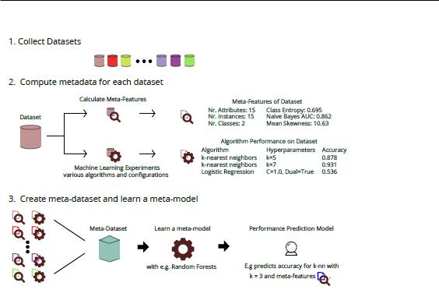

Figure 4.1: A layout of how meta-learning works. 1. Data sets are collected. 2. Meta-data is computed for each dataset. 3. A meta-dataset is created and a meta-model is learned[121].

datasets with a suitable algorithm for high performance and tries to improve this performance by ne-tuning its hyper-parameters. In combination with the machine learning pipelines, meta-learning tries to nd the best ones available. Since not only algorithms must be selected, but also hyper-parameters must be optimized and preprocessing must be done, the time and space needed for meta-learning causes a combinatorial explosion. This can be lessened by stopping the investigation of bad pipelines and limiting the range of hyper-parameters, machine learning- and preprocessing algorithms as much as possible.

Features of the meta-learning phenomenon are used to predict the performance. There are three meta-features categoriesG.1). The rst category is a combination of simple, statistical and information-theoretic computations of a dataset. They can be a basic feature of the data set, as well as a value after a statistical computation or a speci c theoretical value (Appendix. The second meta-feature category can be called landmarks. Landmarks give the performance of algorithms, how well they are doing with the given data set. The last meta-feature category is model-based. Speci c characteristics of the used model can be used as meta-features as well[123, 124].

For using those meta-features in picking the best machine learning algorithm meta-learners can be used. Meta-learners are algorithms that choose between the possible choices. There are four ways of doing that. The rst is plainly choosing the best algorithm in the set, this choice speeds up the process but is prone to being a bad choice. Second a subset of good algorithms can be chosen, which is slower, but has a higher chance to give a good outcome. Thirdly the algorithms can be ranked, which makes the chance of picking a good algorithm quicker starting at the top. Fourth is to use estimations of performance which gives information expectations over all algorithms[125].

Tree-based Pipeline Optimization Tool

Tree-based Pipeline Optimization Tool (TPOT) is a tool that implements autoML. It uses the machine learning pipelines and evolutionary optimization to nd the best solution for every data set. This evolutionary optimization is done by genetic programming. Genetic programming evolves

26

4.2. BACKGROUND T.P.A. Beishuizen

Table 4.2: All TPOT Algorithms used for the TPOT classi er function. Not only the algorithms di er, but also the hyper-parameters within these algorithms.

Algorithm type Speci cation |  | Algorithms
 | Na•ve Bayes | GaussianNB, BernoulliNB, MultinomialNB
 | Decision Tree | DecisionTree, ExtraTrees, RandomForest,
Classi er | Decision Tree | GradientBoosting
 | Nearest Neighbour | KNeighbours
 | Support Vector Machines | LinearSVC
 | Logistic Regression | Logistic Regression
 | Scaler | Binarizer, MaxAbsScaler, MinMaxScaler,
 | Scaler | Normalizer, RobustScaler, StandardScaler
Preprocessors | Feature reduction | PCA, FastICA, RBFSampler, Nystroem,
 | Feature reduction | FeatureAgglomeration
 | Feature Modi er | Polynomial, OneHotEncoder,ZeroCount
 | Feature Selectors | SelectFwe, SelectPercentile, VarianceThreshold,
 | Feature Selectors | RFE, SelectFromModel

possible solutions to nd a better solution. This evolution is done by rst evaluating them and selecting the best ones to continue to the next generation. Then both crossovers between and mutations on possible solutions are performed. After that again evaluation and selection, followed by crossovers and mutations, take place a number of times until a certain quality is found, time has run out or another ending condition has been met.

TPOT makes use of this genetic programming with using the machine learning pipelines in a tree (Figure 4.2). TPOT consists of preprocessing and machine learning algorithms, that form the backbone of the pipelines (Table 4.2). Their hyper-parameters are the variables. TPOT makes mostly use of the machine learning and preprocessing algorithms of scikit-learn from Python in which it is also written, but also several additional algorithms are present (e.g. a hot encoding algorithm).
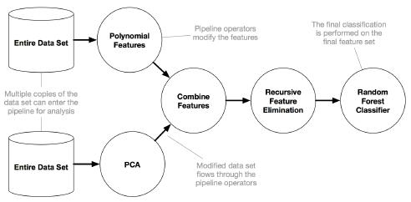

Figure 4.2: An example of a machine learning pipeline in TPOT. It only shows the primitive algorithms and not hyperparameter terminals. At the root is the machine learning algorithm[121].

TPOT has three di erent types of mutations within one pipeline.The rst one is insertion, inserting a primitive somewhere in the tree. An example would be the insertion of an additional preprocessing algorithm. The second one is replacement, which replaces a random terminal. It can for example change a binary hyper parameter from true to false. The third one is shrinking.

27

4.2. BACKGROUND T.P.A. Beishuizen

A primitive is replaced by a terminal. For example a preprocessing step can be replaced by just raw data. This di erent mutations can all be seen visually (Figure 4.3)
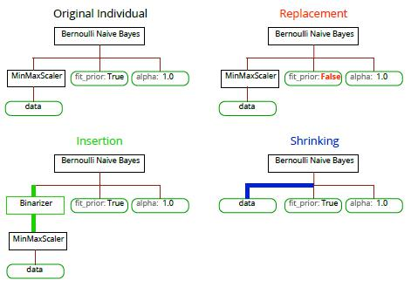

Figure 4.3: Examples of the three mutations in the TPOT algorithm: insertion, replacement and shrinking[121].

TPOT also focuses on mutations between two pipelines by means of crossovers. Between two pipelines, sub-trees and primitives can be changed, given that the both pipelines remain valid (Figure 4.4). Every time a crossover is performed, two separate pipelines are used and changed, creating two new ones.
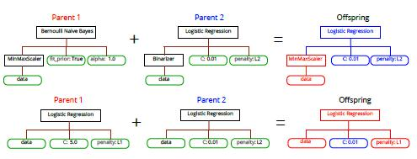

Figure 4.4: An example of a TPOT crossover[121].

Considering the capabilities from TPOT to cope with challenges in biomedical data, several methods are available. It has several di erent normalisation/standardisation scalers (Standard-Scaler, RobustScaler, MinMaxScaler) to tackle feature heterogeneity between di erent data sets and errors. It also has some feature selection operators to tackle errors (VarianceThreshold, Selec-tKBest, SelectPercentile). At last, if missing values are present it, imputes the median for those values before starting the evolutionary algorithm.

28

4.3. HYPOTHESES T.P.A. Beishuizen

4.3 Hypotheses

The main goal for this chapter is to nd more insight in feature selection and add that insight to the nal framework. Several hypotheses are made before designing experiments to test them and are discussed here:

- Optimum in number of selected features

An optimum should be found in the number of selected features. Whereas using too many features may cause issues for a machine learning algorithms to extract the correct infor-mation from them, preserving too few features may result in lost information. Previous research scaled down the number of features from 400 to 96[126], 500 to 13 and for even bigger datasets from 5000-100000 features to between 200 and 900 relevant features[127]. Interestingly, the number of relevant features was not related to the original feature set size, indicating the optimum to be an absolute number. Therefore:

H1: The value of this absolute optimum is estimated to be lower than 1000, as no study before ever used a lower number of relevant features.

- Best feature selection methods

Three types of feature selection methods are discussed, all of them having a their own ad-vantages. Out of these three, the embedded methods are expected to outperform the others. Whereas lter methods are quick and easy, their e ciency should be lower the lower than the other methods. Wrapper methods are more close to trying to nd the optimal solution the exhaustive way and therefore are expected to perform the best feature selection at a cost of computation e ciency. At last the embedded methods are expected to be in between of the two. The embedded methods use machine learning methods that are fairly quick and easy to understand to nd the results and those machine learning methods somewhat use relative contributions between features. This would mean that embedded methods are quicker and easier than wrapper methods and more e cient than lter methods and therefore combining the best of both.

H2: The embedded methods are expected to outperform lter methods in quality and wrapper methods in computation time e ciency.

- TPOT feature selection integration

Integration of feature selection in TPOT for the framework can be done in di erent ways. Two ways are thought to be a bene cial addition to the tool. First expanding the number of feature selection methods should improve TPOT in nding better pipelines. Secondly hav-ing TPOT start with an initial pool of pipelines including feature selection methods should give it a head-start and therefore be quicker and better and nding good pipelines.

H3: Both additions (warm starting with feature selection methods and additional feature selection methods) are expected to improve TPOT with feature selection.

29

4.4. METHODS T.P.A. Beishuizen

4.4 Methods

For empirical evaluation the collection of feature selection methods experiments are done. The quality of the feature selection is tested by de ning a de nition of quality rst. After that an exploration of feature selection is done with lter methods, followed by comparisons of multiple feature selection methods. The four example datasets (subsection 6.2.1) were used as example datasets for the experiments.

4.4.1 Feature Selection Quality

To nd out the quality of the feature selection, multiple machine learning algorithms are used[128]. Classi cation of the datasets can be done with several machine learning algorithms and validation and tests scores show how well the data can be classi ed after feature selection. The quality will be described with the accuracy of machine learning algorithms: the number of right classi cations divided by the total number of classi cations. Five di erent machine learning classi ers are used from scikit-learn: logistic regression, decision trees, nearest neighbour, support vector machines and Naive Bayes. Better feature selection algorithms have relatively higher accuracy, as they are better at preserving the right features. Since over tting sometimes happens when tting data in a machine learning algorithm, both a validation and a test score is computed for the accuracy. For every experiment a training set and a test set is created, making the test set 20% of the complete dataset. A validation score is computed by using the "leave one out" technique on the training set and a test score is computed by testing the classi cation score of the test set. Since the samples are not evenly distributed over the classes the precision, recall and F1 scores are also computed to nd potential bias in the result.

In some cases the quality of the machine learning algorithm lacks a factor of feature subset size. The accuracy in those cases is not su cient enough to evaluate the result. To incorporate the quality of feature selection a new modi ed quality term FS accuracy is created (Equation 4.4.1). In FS accuracy a modi ed version of the original accuracy is given by rst multiplying it by a a factor dependent on the number of features. This factor consists of a constant , a value in range [0; 1] which can be chosen for the in uence of the value that represent the number of features. In practice > 0:95 so the reduction does not have too much in uence on the accuracy. An example plot of how the correction factor changes is given (Figure 4.5).

FS accuracy = accuracy ^{#features}

30

4.4. METHODS T.P.A. Beishuizen
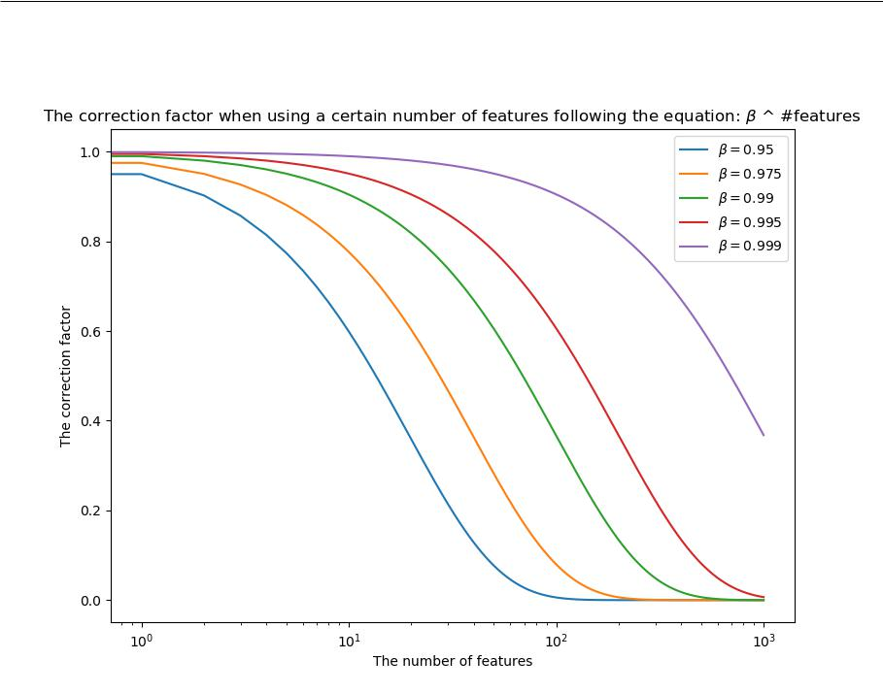

Figure 4.5: The correction factor for the FS accuracy from Equation 4.4.1. Every graph corre-sponds to a di erent value of .

The factor #features is an absolute count, instead of a relative count (for example a percentage of features). Th reason for using an absolute count can be found in the goal of the data analysis. In data analysis the number of features that can be relevant are very limited. Useful results need relations between the input and the output, and these relations need to be as simple as possible. If the number of features is relative to the total number of features, the input size can change signi cantly. Take for example the Micro-organisms and the RSCTC datasets provided for this study (Subsection 6.2.1). 2% of the total features would be 26 and 1100 features for these datasets respectively. Whereas relations between 26 features and the output is possible to understand, relations between 1100 features and the output is much harder. Taking an absolute number of features allows for a more active choice on the input size.

To put the impact of the FS accuracy in perspective, an example gure is made how the outcome is computed (Figure 4.6). This gure shows the impact on the performance of a method when using a certain number of features. After using a correction factor, an optimum is created for which the number of features is important, the old optimal accuracy did not include the number of features. The example (with = 0:99) seems to give a good indication of the desired outcome. For every 10 features, the FS accuracy is reduced by about 10% (Figure 4.5), which meant for the example lter method that for 50 features an optimum was reached (Figure 4.6). Because of this empirically found desired trade-o , = 0:99 will be chosen in this project when using FS accuracy.

31

4.4. METHODS T.P.A. Beishuizen
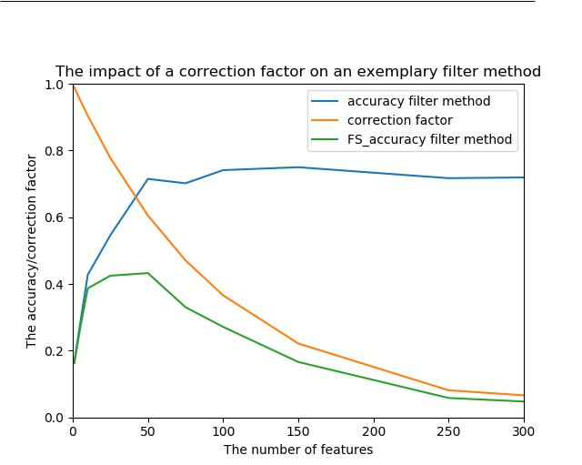

Figure 4.6: An example of the impact of the correction factor on the accuracy. The shown correction factor uses = 0:99. On the x-axis the number of features is shown and on the y-axis the value for the original accuracy, the correction factor and the FS accuracy.

4.4.2 Feature Selection Exploration

The rst set of experiments is used to explore a combination of the basic lter method combined with the quality measurements. The basic lter method algorithm selecting the top n features (Algorithm 1) is used. The changing variables are the dataset, the ranking method, the feature preservation values and the accuracy computation methods (Table 4.3). The range of chosen feature preservation values comes from both its ability to show impact of separate features (more impact from fewer features) and the relevance of keeping that number of features (irrelevant feature selection when having more than 1000 features). All of this together results in a total of 4(datasets) 2(ranking methods) 11(top n features) 5(accuracy computation methods) = 440 experiments. These experiments are visualized in eight plots, one plot for every combination of data set and ranking method. These plots then show the change in quality for di erent number of preserved features.

4.4.3 Feature Selection Algorithms Evaluation

The second set of experiments compares the feature selection methods in both feature selection and quality. For this experiment the four datasets are used with the logistic regression quality measurement, since the logistic regression gave the most consistent result of the ve machine learn-ing algorithms, showing the smallest variation across the datasets. The average performance for

32

4.4. METHODS T.P.A. Beishuizen

Table 4.3: The four meta-parameters with their possible values in the rst experiment.

Variable | Description | Values
 |  | Psoriasis
 |  | RSCTC
Dataset | The datasets used (subsection 4.2.1) | Arcene
 |  | Micro-Organisms
 |  | {
 | The method used for ranking | T-test (SciPy)
Ranking method | The method used for ranking | Mutual Information (scikit-learn)
Ranking method | the features ( Subsection 4.2.2) | Mutual Information (scikit-learn)
 | the features ( Subsection 4.2.2) | {
 | The xed size of the feature subset | 1, 5, 10, 25, 50, 75,
Feature preservation values | The xed size of the feature subset | 100, 150, 250, 500, 1000
Feature preservation values | after feature selection | 100, 150, 250, 500, 1000
 | after feature selection | {
 |  | Naive Bayes
 | The machine learning algorithms | Logistic Regression
Accuracy computation | The machine learning algorithms | Support Vector Machine
Accuracy computation | used to compute accuracy (subsection 4.4.1) | Support Vector Machine
 | used to compute accuracy (subsection 4.4.1) | Decision Tree
 |  | Nearest Neighbours

all datasets is also computed for clari cation purposes. An overview of feature selection methods is made (Table 4.4) and all separate meta-parameters are explained here.

Filter methods

The ranking methods T-test and Mutual Information were used as those were both explored in the rst experiment. The thresholds of 50, 100 and 150 features were chosen as a com-promise between the desired number of features (as few as possible) and the quality of the result (as explored in the rst experiment).

Wrapper methods

The order of the features used for feature selection with wrapper methods was put at random (no special ordering) or with mutual information (special ordering). The evaluation was chosen to be Naive Bayes as it is simple and not much a ected by conditional dependency. The aforementioned threshold value for wrapper methods was chosen to be 0.01 and 0.001 with a maximum number of features in mind. If = 0:01, a feature will only be added when it raises the quality by 0.01. The accuracy can be at most 1, so at most 100 features can be added, even though the nal number of features would be much less. = 0:001 was taken for a solution with a higher accuracy in mind. At last, for the PTA method, for l and r

the combinations [l; r] = [5; 2] and [l; r] = [20; 10] were chosen. The ratio was picked close to 2 : 1 as a compromise between number of features added and removed, 50% being a a reasonable ratio to still keep a decent number of features. The size of l and r were di erent in a factor 4 or 5 to nd out if this size di erence would make a change.

Embedded methods

The machine learning algorithms that were tested were Support Vector Machines (SVM) and RandomForests (rf), as both of them have a measurement of feature importance. The number of features preserved was put on 50, 100 and 150 being the same as for the lter methods.

Spectra are made with the results of the experiment that show the performance of all di erent combinations, showing the accuracy, precision, recall and F1-score. On top of that the computation time is computed and shown per algorithm, as well, in a separate bar chart. At last a combination of the earlier proposed FS accuracy and the computation time is shown as well for = 0:99 to show the relation between computation time on one hand and the FS accuracy on the other hand.

33

4.4. METHODS T.P.A. Beishuizen

Table 4.4: The methods that are evaluated in the second experiment setup.

Type | Method | Parameters
Filter methods | Basic Filter Methods | - Rank: T-test, Mutual Information
Filter methods | (Algorithm 1) | - Thresholds: 50, 100, 150 features
 |  | - Order: Random, Mutual Information
 | Forward selection | - Evaluation: Naive Bayes
Wrapper methods | (Algorithm 3) | - Alpha: 0.01, 0.001
Wrapper methods |  | {
 |  | - Order: Random, Mutual Information
 | PTA | - Evaluation: Naive Bayes
 | PTA | - [l, r] = [20, 10], [5, 2]
 | (Algorithm 5) | - [l, r] = [20, 10], [5, 2]
 | (Algorithm 5) | - Alpha: 0.01, 0.001
 |  | {
 | Floating search | - Order: Random, Mutual Information
 | Floating search | - Evaluation: Naive Bayes
 | (Algorithm 6) | - Evaluation: Naive Bayes
 | (Algorithm 6) | - Alpha: 0.01, 0.001
Embedded methods | Forward selection | - Machine Learning: SVM, RandomForests
Embedded methods | (Algorithm 8) | - Threshold: 50, 100, 150 features

Several discussed algorithms are chosen to be excluded from the evaluation. This choice is based on their poor scalability with regards to computation time and therefore un t for datasets with this many features. These excluded algorithms are the backwards elimination sequential method, the simulated annealing stochastic search method and the embedded backwards elimination method (Subsection 4.2.2).

4.4.4 TPOT Feature selection integration

TPOT is an e ective tool to nd the best machine learning pipeline for a certain dataset (Sub-section 4.2.3). TPOT however has three restrictions on nding the correct pipeline when a high number of features is involved:

- Input versus output

The goal of feature selection is to directly link a smaller number of features to the output. Whereas TPOT has possibilities to nd pipelines with feature selection, it gives no advantage to pipelines that actively use feature selection if needed.

- Memory/Invalid dataset issues

Firstly, not all algorithms are suitable for handling more than 10000 features. The feature agglomeration algorithm, one of the algorithms present in TPOT, will create memory issues in those cases. This makes this algorithm un t for usage. Similarly, the scikit-learn multi-nomial naive bayes algorithm cannot be used with negative values. Biomedical data does not have that restriction and therefore possibly gives errors because of this. On top of that, several preprocessing algorithms also change values to be negative.

- General insert issue

After some testing and consultation it was concluded that inserting new algorithms to a pipeline created issues in TPOT. This issue resulted in a very low number of insertion mutations, which caused a suboptimal search for the best machine learning pipeline that includes feature selection methods and insertion of those.

These three initial restrictions must rst be tackled for proper use of TPOT with feature selection. This resulted in three measures, explained here in corresponding order.

34

4.4. METHODS T.P.A. Beishuizen

- Feature modi er addition to accuracy

In the case of feature selection, the possibility is given to change the performance measure-ment to the earlier proposed FS accuracy. Using this FS accuracy instead of normal accuracy creates an incentive for TPOT to prefer feature selection algorithms in the resulting pipeline, due to higher performance.

- Algorithm removal

For this restriction, simply the feature agglomeration algorithm is removed. This type of feature selection is not essential in biomedical research and therefore removal is not expected to hinder removal. The multinomial naive bayes algorithm is removed, as well, with the same reasoning.

- Change in insert method

This insert issue was removed by rewriting the code for the insert function. This insert function originally attempted to insert algorithms for every possible hyper-parameter as well as at the start of the pipeline. This is replaced by only having insertion at the start of the pipeline This is an improvement because no algorithm in TPOT actually has a hyper-parameter that can be changed by a di erent algorithm in TPOT.

On top of these three restrictions and the measures taken to tackle them, two additional restrictions hinder optimization with regards to feature selection:

- Lack of warm start

TPOT has a vast array of machine learning and preprocessing algorithms to nd the best possible pipeline. Due to the number of possibilities being very high, a lot of time may be wasted due to searching in wrong directions. For feature selection, a pre-de ned selection of pipelines (also known as a warm start) would improve e ciency.

- Feature selection possibilities

Several lter and embedded methods are present (Subsection 4.2.2). All of these select percentages of feature selection, though. Still a high number of features can be present in the result after using percentages. On top of that, no wrapper methods are available, either.

For both of these optimization restrictions, two additions are made to the TPOT code structure for increased functionality with regards to feature selection, in the same order as the restrictions:

- Focused feature selection addition

The possibility is created to start the original population with guaranteed a feature selection algorithm in the feature selection pipeline. Due to this start the expected search for a good feature selection method is bypassed immediately, which should result in more optimized nal pipeline.

- Alternative feature selection algorithm set

The possibility is created to start with an alternative feature selection algorithms set. This selection consists of lter, wrapper and embedded methods and the hyper-parameters are prede ned to create an upper bound of 200 features.

The outcome of the rst initial measures are trivial: the use of FS accuracy makes TPOT search for solutions with fewer features. The removal of algorithms that cause errors and memory issues creates better optimization. Furthermore more e ective use of the insert evolution, makes the algorithm make better use of that possibility. The outcome of optimization additions however may not necessarily improve the performance of TPOT for feature selection. Therefore the changes for these two solutions are tested with an experiment.

The experiment consists of multiple runs of TPOT and all of these steps are also shown in an explanatory table (Table 4.5). All four datasets are tested (Subsection 4.2.1) and the accuracy is changed to the feature sensitive FS accuracy with = 0:99 (Equation 4.4.1), as previously

35

4.4. METHODS T.P.A. Beishuizen

Table 4.5: The experiment details for testing the non-trivial changes in TPOT. This experiment is rerun 5 times.

Experiment | Detailed values |  |  | Remarks
factors |  |  |  | Remarks
 | Micro-organisms
Datasets | Arcene |  |  | High number of features
Datasets | RSCTC |  |  | (Subsection 4.2.1)
 | Psoriasis
Performance | One type: FS |  | accuracy | Addition of correction factor
measurement | - = 0:99 |  |  | (Equation 4.4.1)
 | One set of input values: |  |  | Explanation of input values:
TPOT input | - max. optimization time = 120 min |  |  | - The time one run should take (2 hours)
TPOT input | - max. alg. evaluation time = 10 min |  |  | - The evaluation time of one pipeline
parameters |  |  |  | - The evaluation time of one pipeline
parameters | - pop. size = 12 |  |  | - The number of pipelines in one generation
 | - train size = 0.9 |  |  | - The number of samples used for training
Pipeline | Regular selection |  |  | Possible obligatory addition
selection | Feature selection focused |  |  | of a feature selection algorithm
Change in |  |  |  | A change between several basic
Change in | Regular feature selection algorithm set |  |  | feature selection algorithms to
feature selection |  |  |  | feature selection algorithms to
algorithm set | New feature selection algorithm set |  |  | feature selection algorithms designed
algorithm set |  |  |  | for at most 200 features preservation

discussed (Subsection 4.4.1). For testing TPOT an optimization time of 120 minutes (two hours) was chosen as a reasonable time constraint to run each experiment 5 times, an algorithm was not allowed to run for longer than ten minutes, a population size of 12 was chosen to not be to selective at the start and a training set size of 0:90 which is a general training set size when not many samples are present. Furthermore tests were done for pipeline selection both with and without focused feature selection and for both with and without alternative feature selection algorithms set, as these additions must be tested for their quality. This gives a total of 4(datasets) 2(pipeline selection) 2(feature selection set) 5(experiment reruns) = 16 di erent experiments.

36

4.5. RESULTS T.P.A. Beishuizen

4.5 Results

The di erent experiments are all explained in their own subsections. First the results of the minimum feature preservation experiment were shown, followed by the feature selection algorithms evaluation.

4.5.1 Feature Selection Exploration Results

The results were plotted for every dataset separately (Appendix E.1). An average of the four datasets was also created to show the di erence between validation and test score (Figure 4.7), between machine learning quality measures (Figure 4.8) and between data sets with ranking meth-ods (Figure 4.9).
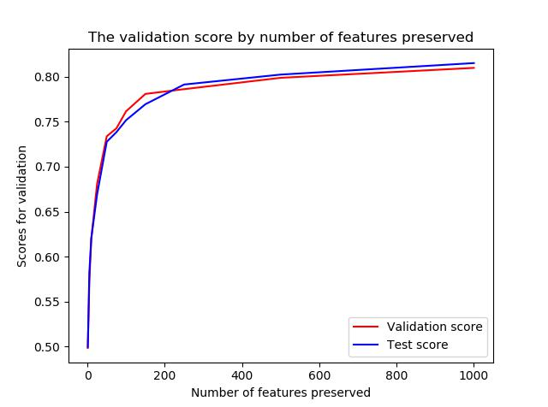

Figure 4.7: The average validation and test scores after averaging the scores for the data sets and ranking methods.

As could be seen (Figure 4.7) the di erence between the validation and the test scores was very low. The average almost showed two identical curves which indicates that there was hardly any over tting present for lter methods. The test error should not be higher than the validation error usually, but in this case the test error had a higher variance. The test error was only one measurement (after splitting the data into training and test set) and the validation error was found with leave-one-out, which should have a much lower variance. Because of the lower variance, the validation score was used in the other two gures (Figures 4.8 and 4.9).

37

4.5. RESULTS T.P.A. Beishuizen
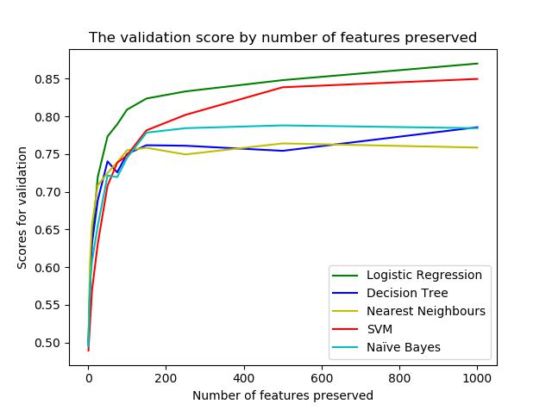

Figure 4.8: The average validation accuracy shown per machine learning quality measurement.

Logistic regression gave the best validation scores taking all data sets combined, followed by SVM. Also, when looking at all eight plots separately (Appendix E.1), logistic regression also showed the most consistent behaviour. All ve of the machine learning algorithms showed an 'elbow', an area in the graph for which the score stops growing as much when more features are used. This 'elbow' was located around 100 features with 200 features being the end for almost every 'elbow'.
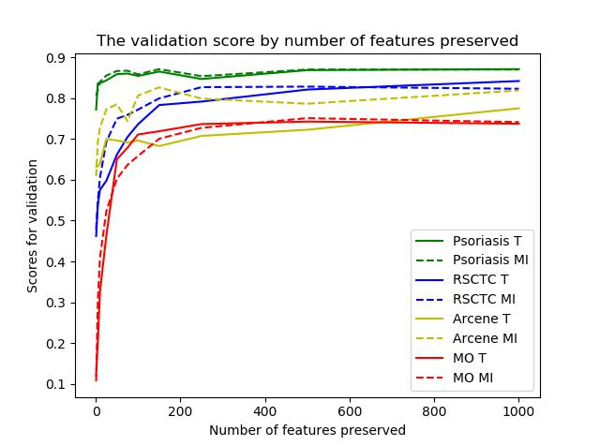

Figure 4.9: The average validation accuracy shown per dataset and rank.

A di erence in score quality for the datasets was visible (Figure 4.9). The di erence between using Mutual Information and T-test/ANOVA was not, as for only the Arcene dataset there was a signi cant di erence between the two. Therefore it seems that the ranking method type has less in uence on the measurement quality. One interesting aspect was that methods using Mutual

38

4.5. RESULTS T.P.A. Beishuizen

Information had a longer computation time than methods using the T-test/ANOVA.

Accuracy was used to test the validation quality of the lter methods. Aside from accuracy the precision, recall and F1-score were also computed to nd out whether accuracy is a proper representation of the quality (Figures 4.9 and 4.10 and Appendix E.2). These scores showed that the accuracy is a plausible way to depict quality and it is not needed to use F1-score. Only the Arcene dataset shows some di erence between accuracy, precision, recall and the F1-score but these di erences would not a ect any conclusions.
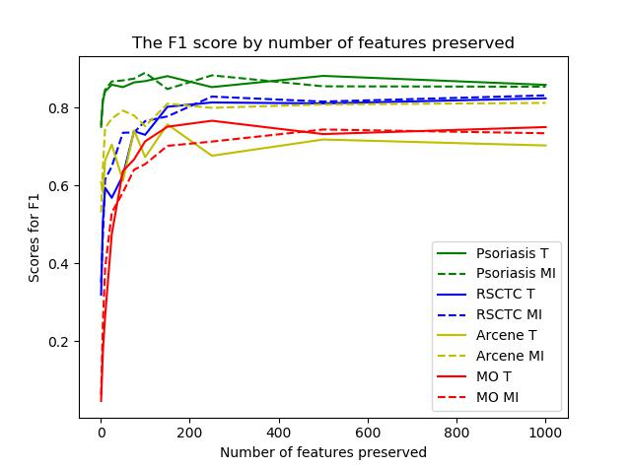

Figure 4.10: The average validation F1-scores shown per dataset and rank.

4.5.2 Feature Selection Algorithms Evaluation Results

Spectra using all basic lter methods and wrapper sequential search methods were created, aver-aging the accuracy (Figure 4.11), precision (Appendix E.3), recall (Appendix E.3) and F1 score (Figure 4.12) of the four datasets. The gures showed that all wrapper algorithms preserved on average less than 61 features for these settings, whereas the performance seems to average around 75% for all four performance scores. The lter and embedded methods performed worse, with an overall lower performance score than the wrapper methods, even when more features were present. Also, no immediate observations can be made by looking only at the lter and embedded algorithms.

When only looking at the wrapper algorithms, some other observations could be done, as well. Ordering the features before using a wrapper method structurally gave a better result than using a random ordering. Also a threshold of = 0:001 usually resulted in more features and in a higher scores in comparison with a threshold of = 0:01. Comparing the algorithms, the oating search with ordering did best in performance, whereas the other algorithms are performing closer together.

39

4.5. RESULTS T.P.A. Beishuizen
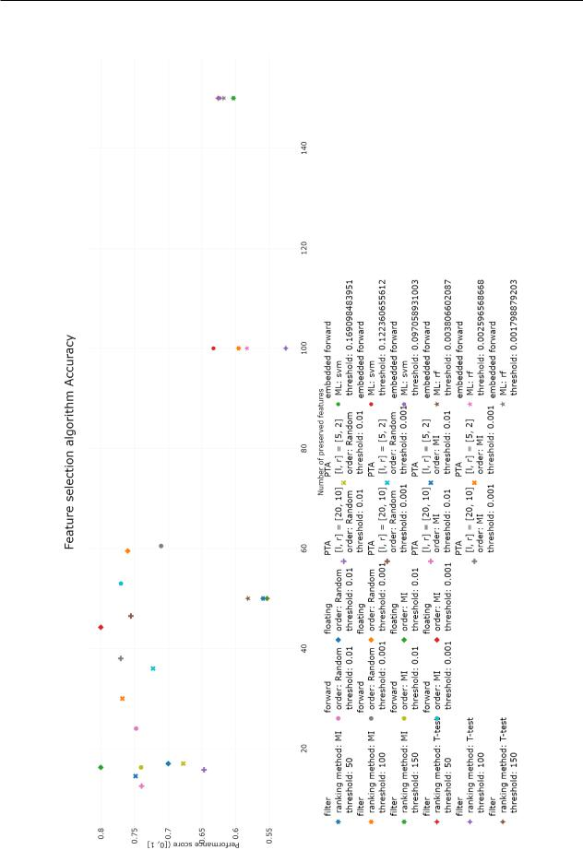

Figure 4.11: The accuracy spectrum for the average dataset. The x-axis shows the average num-ber of features that are preserved and the y-axis shows the accuracy of logistic regression. The legend indicates the algorithms (Table 4.4) and their corresponding shapes, as well as the chosen parameters with their matching colours. Abbreviations in legend: Mutual Information (MI), Pick l-Take Away r (PTA), Machine Learning algorithm (ML), Support Vector Machine (svm), random
forest (rf) | 40

4.5. RESULTS T.P.A. Beishuizen
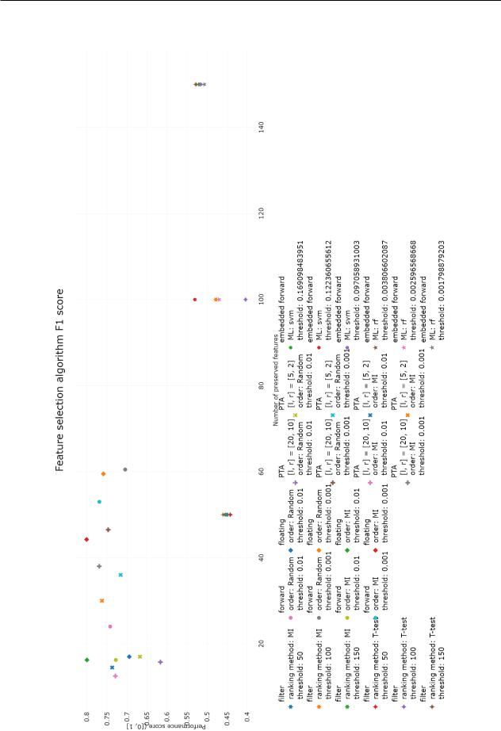

Figure 4.12: The F1 spectrum for the average dataset. The x-axis shows the average number of features that are preserved and the y-axis shows the F1 score of logistic regression. The legend indicates the algorithms and their corresponding shapes, as well as the chosen parameters with their matching colours. Abbreviations in legend: Mutual Information (MI), Pick l-Take Away r (PTA), Machine Learning algorithm (ML), Support Vector Machine (svm), random forest (rf)

41

4.5. RESULTS T.P.A. Beishuizen

Aside from the ability to preserve the correct features, also an evaluation of the computation time was made for the di erent algorithms (Figure 4.13). This chart immediately showed that the wrapper methods took signi cantly more computation time, with oating search to be take the longest. There was no major di erence between forward selection and both PTAs, however there was a di erence between lter methods using Mutual Information and T-test. Also for the embedded methods, the SVM based embedded method took signi cantly less time as well, compared with the random forest embedded method.

42

4.5. RESULTS T.P.A. Beishuizen
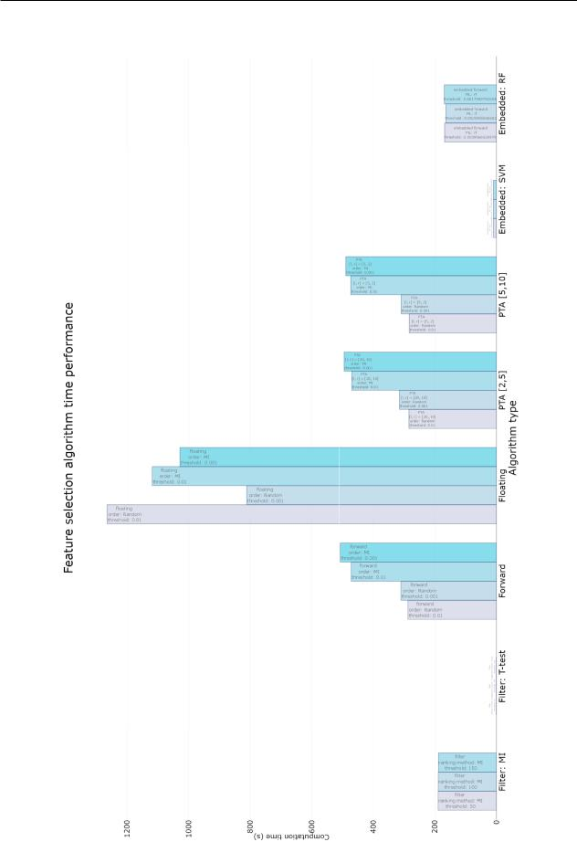

Figure 4.13: A bar chart showing the average computation time of all evaluated algorithms. The x-axis corresponded to the di erent algorithms, for which the computation time for multiple parameter combinations were given. The y-axis corresponded to the computation time in seconds. Abbreviations in legend: Mutual Information (MI), Pick l-Take Away r (PTA), Support Vector Machine (svm), random forest (rf)

43

4.5. RESULTS T.P.A. Beishuizen

At last the relation between the computation time and FS accuracy, the corrected accuracy, are visualized (Figure 4.14). In this chart the trade-of between computation time and quality of a feature selection algorithm is shown by the following statements:

Filter and embedded methods take the shortest time, but have the worst performance. Floating methods takes the longest time, but are not necessarily better than other wrapper methods

For both lter and embedded methods using T-test and SVM over mutual information and random forests respectively seems to greatly reduce computation time for little to no improvement in FS accuracy.

For all wrapper methods the addition of an ordering and choosing a threshold of = 0:01 over = 0:001 gives better results. Using these hyper-parameters however usually add computation time.

Forward selection and PTA do not show a big di erence between each other.

44

4.5. RESULTS T.P.A. Beishuizen
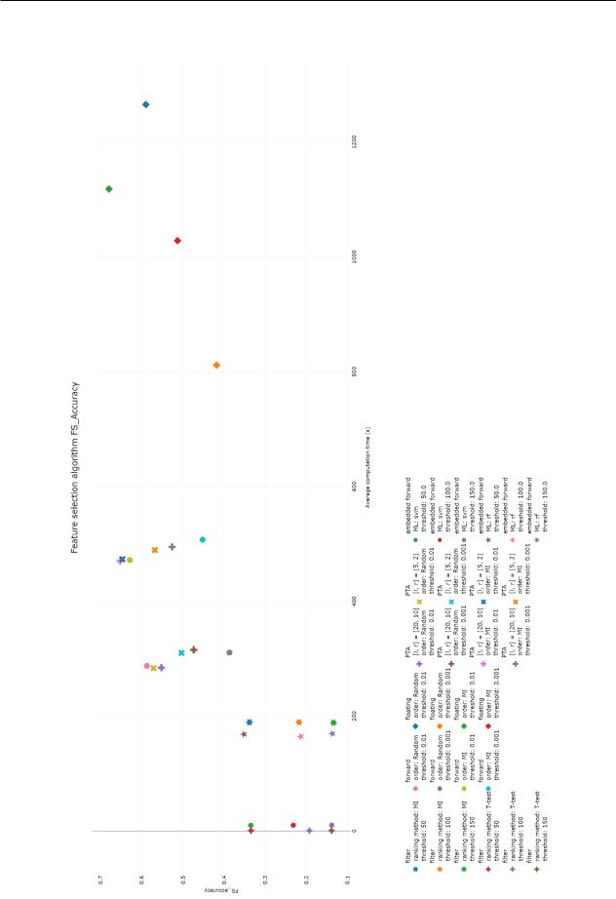

Figure 4.14: The relation between the FS accuracy and the computation time. The x-axis shows the computation time the y-axis shows the FS accuracy score of logistic regression. The legend indicates the algorithms and their corresponding shapes, as well as the chosen parameters with their matching colours. Abbreviations in legend: Mutual Information (MI), Pick l-Take Away r (PTA), Machine Learning algorithm (ML), Support Vector Machine (svm), random forest (rf)

45

4.5. RESULTS T.P.A. Beishuizen

Table 4.6: The performance of the nal pipeline for the di erent types of TPOT and the mentioned dataset. The ve reruns are averaged into this one result.

_{Algorithm} selection |  | regular selection |  | always feature selection
 |  | regular | feature selection |  | feature selection
 | availability | regular | feature selection | regular algorithms | feature selection
 | availability | algorithms | algorithms | regular algorithms | algorithms
 | Micro-organisms | 0.45 | 0.71 | 0.64 | 0.59
Datasets | Arcene | 0.46 | 0.69 | 0.62 | 0.69
Datasets | RSCTC | 0.00 | 0.22 | 0.17 | 0.44
 | Psoriasis | 0.00 | 0.24 | 0.16 | 0.54

4.5.3 TPOT Feature Selection Integration Results

To visualize the results of the experiment, a table with the nal results is made (Table 4.6). The optimization process is also recorded and shown in a plot for the Micro-organisms (Figure 4.15), Arcene (Figure 4.16), RSCTC (Figure 4.17) and Psoriasis (Figure 4.18) dataset. The ve experiment reruns are averaged to one complete result.
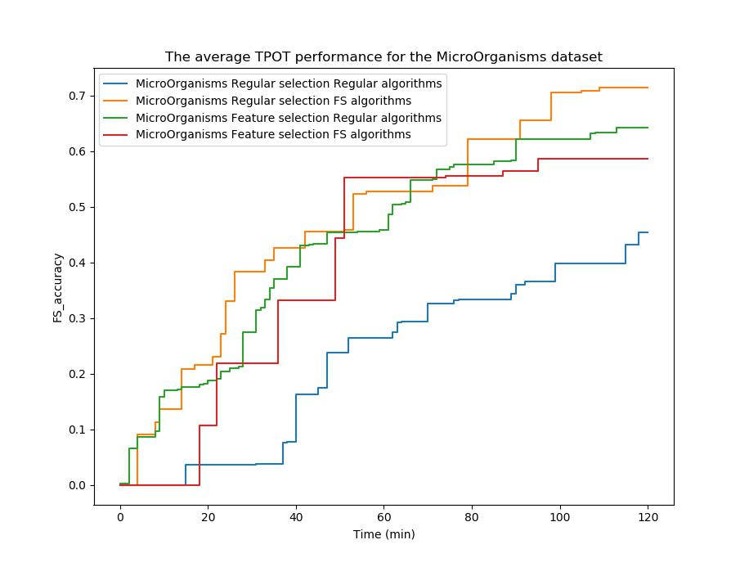

Figure 4.15: The optimization process for the di erent TPOT algorithms for the micro-organisms dataset.

46

4.5. RESULTS T.P.A. Beishuizen
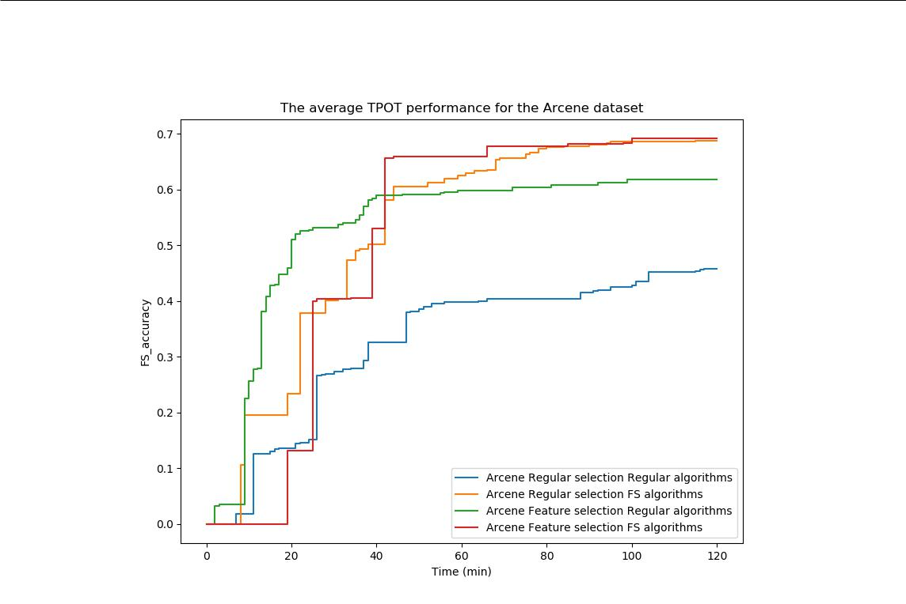

Figure 4.16: The optimization process for the di erent TPOT algorithms for the Arcene dataset.
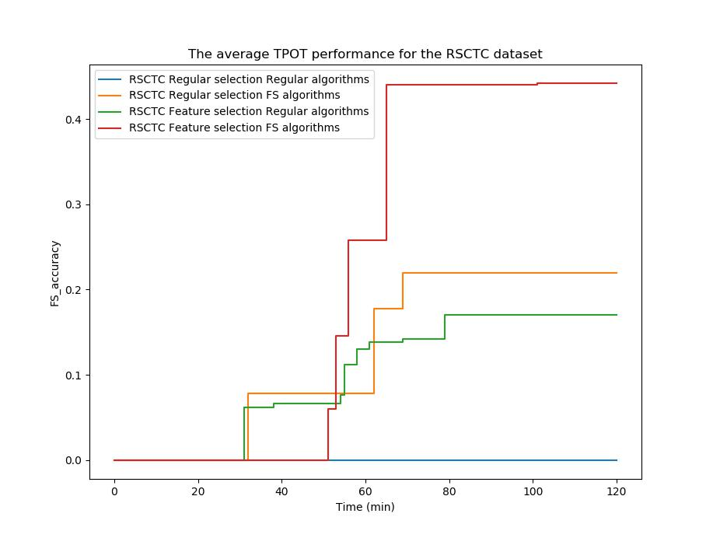

Figure 4.17: The optimization process for the di erent TPOT algorithms for the RSCTC dataset.

47

4.5. RESULTS T.P.A. Beishuizen
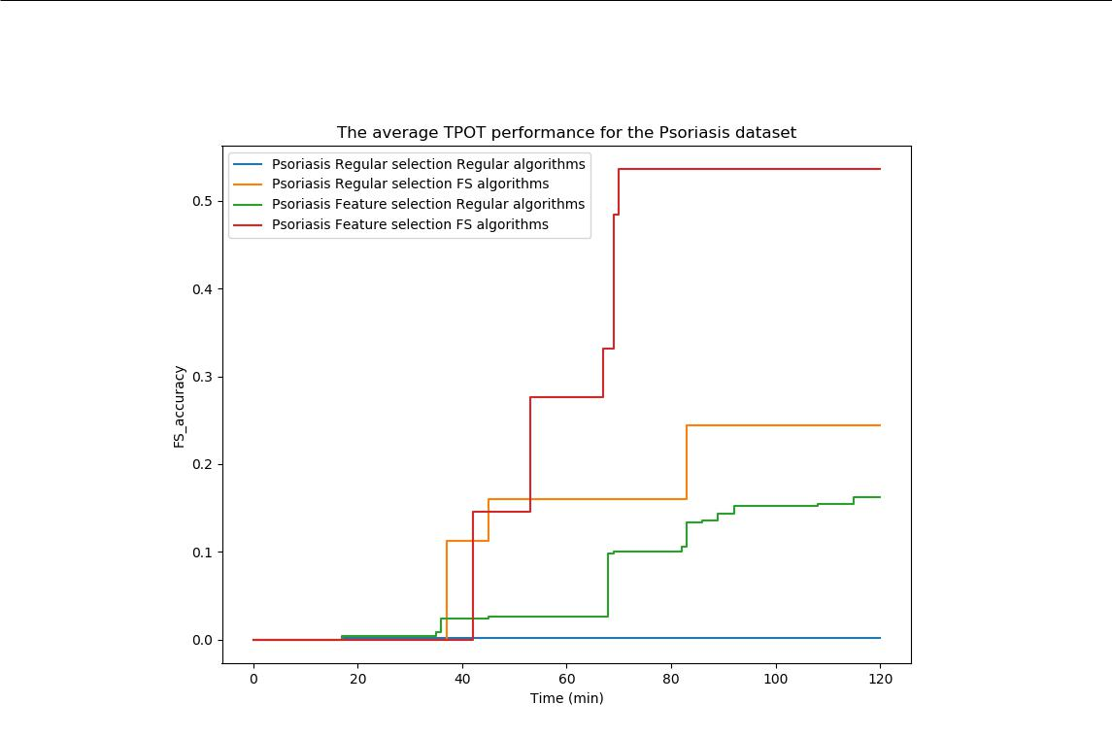

Figure 4.18: The optimization process for the di erent TPOT algorithms for the psoriasis dataset.

The results show that after two hours of running TPOT, regular TPOT always performs worst. According to the processes the high feature selection algorithm set shows much more big stepwise improvements, accompanied with fewer smaller stepwise improvements. This shows the earlier observed trade-o between computation time and feature selection quality for these speci c feature selection algorithms. It takes longer to compute those algorithms, but it also gives a much better result.

The choice for the best TPOT algorithm is not conclusive. For high feature selection, all three new possibilities show an improved results. The TPOT variant that is feature selection focused and has the new feature selection algorithm set performs the best for datasets with a very high number of features (RSCTC and Psoriasis), but the trade-o in computation time seems to hurt the performance for smaller datasets. The algorithm that is only feature selection focused has a steady performance for datasets with a lower number of features, but this performance does not seem to be better than the algorithm with only the new feature selection algorithm set.

48

4.6. DISCUSSION T.P.A. Beishuizen

4.6 Discussion

Several works focused on the possibility of feature selection are present, both with a data analytical[89] as well as a biomedical[19, 20, 90] point of view. These research projects usually focused on datasets with a low number of features, for which feature selection is less relevant. This research for datasets that have a signi cantly higher number of at least 1000 features is new, even though newly avail-able datasets become bigger over time due to new and improved techniques of measuring and storing data. With this research a beginning is made on how to approach feature selection on these bigger datasets.

Whereas multiple feature selection methods are discussed, several were not tested due to com-putation time constraints. The wrapper methods backwards elimination and simulated annealing and the embedded backwards elimination all were too computationally intensive to become rel-evant for the research. In datasets with fewer features, these methods may be showing better results and could be possible candidates for feature selection.

4.7 Conclusions

After evaluation of the results in the rst experiment set-up, it can be concluded that there is not a big di erence between using T-test/ANOVA or Mutual Information as a ranking method. Both seem to give similar results, with the exception of one dataset (Figure 4.9). The T-test/ANOVA is computationally faster than Mutual Information as could be seen in the second experiment (Figure 4.13), however also works with the assumption that the classes are normally distributed. This may not always be the case. A rule of thumb for choice of ranking method would be to use T-test/ANOVA, except for when the data is not normally distributed.

A second conclusion can be drawn from looking at the accuracy with the number of features preserved. After a threshold of 200 features, additional features do not raise the validation score as much as the rst 200 features seem to do. This can indicate a second rule of thumb, that at least 200 features must be preserved after using a lter method. This rule of thumb is according to the hypothesis H1 notion that at most 1000 features should be preserved to still show an e cient result, however is much lower than the expected than the upper bound. This absolute number is not intuitive and much lower than expected. More research can be done on these preserved 200 features and why no other features are needed to predict the output. Cluster analyses for example may show insights in this phenomenon.

After evaluation of both lter, wrapper and embedded methods, wrapper methods seem to be signi cantly better at selecting a smaller fraction of features while preserving a similar test score. Whereas hypothesis H2 stated wrapper methods to be best in e ciency, embedded methods were expected to outperform both lter methods and wrapper methods when looking at both quality and computation time. This is not the case, however, as embedded methods had a near identical quality to lter methods and performed much worse than wrapper methods. The outcome indicates that wrapper methods are signi cantly di erent in results and lter and embedded methods being nearly identical.

Since wrapper methods take dependencies between features into account, they are able to keep these dependencies at a minimum. If these dependencies are unwanted, wrapper methods seem to be more useful than lter methods and embedded and should be recommended. A downside of the wrapper methods however is that they take much more computation time than the lter methods and embedded. Therefore if it does not matter if features have dependencies with each other, a lter method should be recommended.

There is a di erence in quality within the wrapper methods. The forward selection and PTA all showed promising results and therefore should be considered for the framework. Floating search showed the best results, however took signi cantly longer in computation time. Within the wrapper methods, an ordering beforehand is recommended for improved results. Backward elimination wrapper algorithms, stochastic search algorithms and embedded backwards elimination algorithms all were signi cantly worse in computation time than the other wrapper algorithms

49

4.7. CONCLUSIONS T.P.A. Beishuizen

and therefore should not be considered in these cases.

A recommendation for the threshold in wrapper methods is not trivial. A higher threshold of = 0:01 gives a smaller feature subset at the cost of a lower classi cation score. If a smaller subset is desired of high in uence features is needed, a bigger threshold should be chosen, whereas it will be smaller if the quality of the feature subset is better.

In this research only separate feature selection methods are tested. Whereas the lter methods need very little computation time, the feature subset size and quality of the wrapper methods are much more interesting for further research. A combination of a lter and a wrapper method might create a better result. If rst the majority of the features is ltered out by a lter method and then a wrapper method computes the best combination of feature, the result can be relatively quicker than the wrapper method while still maintaining a high enough quality. This combination is worth investigating into in future research.

Both additions to TPOT are bene cial according to the experiment. This is also expected, as H3 states. When the initial number of features is very high (50.000), a combination of initial bias towards feature selection and using feature selection algorithms focusing on preservation of only 200 features performs best. For lower number of features only adding one of the improvements is better, as computation time becomes the limiting factor in case of using both improvements.

50

